**UNIVERSITY OF TRANSPORT AND COMMUNICATIONS**

**FACULTY OF INTERNATIONAL EDUCATION**

--------------



**BACHELOR THESIS**DEVELOPING A STRATEGIC ONLINE PRESENCE FOR HENEI DIMSUM RESTAURANT THROUGH A MODERN WEB PLATFORM

**Fullname** **:** Phạm Thành Duy

**Student ID**  **:** 882126009

**Class** **:** Vietnamese – English Information Technology

**Supervisor**  **:** Dr. Phạm Đình Phong

***Hanoi – 2025***

**UNIVERSITY OF TRANSPORT AND COMMUNICATIONS**

**FACULTY OF INTERNATIONAL EDUCATION**

--------------



BACHELOR THESIS  
DEVELOPING A STRATEGIC ONLINE PRESENCE FOR HENEI DIMSUM RESTAURANT THROUGH A MODERN WEB PLATFORM

**Fullname** **:** Phạm Thành Duy

**Student ID**  **:** 882126009

**Class** **:** Vietnamese – English Information Technology

Supervisor : Dr. Phạm Đình Phong

*Hanoi – 2025*

ACKNOWLEDGEMENT

First of all, I would like to express my deep gratitude to all the teachers of the Department of Information Technology, University of Transport and Communications. During the 5 years of studying at the school, the teachers dedicatedly taught and imparted to me not only valuable professional knowledge but also extremely useful skills and practical experiences. The enthusiasm and dedication of the teachers have helped me continuously progress, improve myself and prepare well for my future career.

In particular, I would like to express my sincerest and deepest gratitude to Dr. Pham Dinh Phong. He was not only a dedicated guide throughout the process of carrying out my thesis, but also someone who closely monitored, accompanied and supported me to overcome difficulties. Your enthusiasm and sense of responsibility have inspired and motivated me to do my best in studying and researching.

During the process of making the graduation project, although we have tried our best, due to limited knowledge, shortcomings cannot be avoided. I look forward to receiving valuable feedback from teachers to improve and improve my knowledge in this field. The teachers' help will be a source of motivation and guidance for me to continue to strive and learn continuously.

Finally, I would like to wish all teachers good health, happiness and success in their teaching careers. I hope that teachers will continue to guide and impart knowledge to more generations of students, helping them firmly on their career path and contributing to building a developed and progressive society. I sincerely thank you!

**TABLE OF CONTENTS**

CHAPTER 1. OVERVIEW AND REQUIREMENTS ANALYSIS 8

1.1. Background 8

1.2. Objectives 9

1.3. Scope 10

1.3.1. In scope 10

1.3.2. Out of scope 11

1.3.3. Users 11

1.4. Approach 12

1.4.1. User interface layer 12

1.4.2. Service layer 12

1.4.3. Data layer 13

1.5. Requirements method 13

1.6. Workflows 14

1.6.1. Customer ordering workflow 15

1.6.2. Restaurant intake workflow 15

1.6.3. Menu maintenance workflow 15

CHAPTER 2. SYSTEM ANALYSIS AND DESIGN 17

2.1. Design Basis 17

2.1.1. Core design goals 17

2.1.2. Technology rationale 18

2.2. Architectural Design 19

2.2.1. Layered architecture 19

2.2.2. Deployment and environment boundaries 20

2.2.3. Directory structure as a design artifact 21

2.3. Functional Design 22

2.3.1. Customer functions 22

2.3.2. Administrator functions as future scope 23

2.3.3. Requirements classification 24

2.4. Use Cases and Interaction Design 25

2.4.1. Use case model 25

2.4.2. Activity workflows 27

2.4.3. Sequence interactions 28

2.5. Data Design 30

2.5.1. Data modeling principles 30

2.5.2. Collections and entities 31

2.5.3. Schema validation and constraints 33

2.5.4. Indexing strategy 34

2.6. API Design 35

2.6.1. API style and semantics 35

2.6.2. Dishes endpoints 36

2.6.3. Orders endpoints 37

2.6.4. Error model and validation responses 38

2.7. Security and Quality Controls 39

2.7.1. CORS and browser security boundary 39

2.7.2. Authentication readiness and JWT considerations 40

2.7.3. Threat awareness 41

2.8. UI Navigation and Menu Structure 42

CHAPTER 3. SYSTEM IMPLEMENTATION 45

3.1. Project folder structure 45

3.1.1. Client structure 45

3.1.2. Server structure 46

3.1.3. Runtime scripts and developer workflow 47

3.2. Customer and admin features 47

3.2.1. Customer features 48

3.2.2. Administrator features and readiness 49

3.2.3. Data correctness and user feedback behavior 49

3.3. Authentication and authorization (JWT)\ 50

3.3.1. Token model 50

3.3.2. Authorization enforcement 50

3.3.3. Security oriented error handling 50

3.4. CORS configuration and environment variables 51

3.4.1. Cross origin boundary 51

3.4.2. Environment variables and configuration loading 51

3.4.3. Practical configuration discipline 52

CHAPTER 4. DEPLOYMENT AND OPERATIONS 53

4.1. Development environment 53

4.2. Frontend deployment 54

4.3. Database deployment 55

4.3.1. Cluster provisioning and connectivity 55

4.3.2. Network access control 55

4.3.3. Data initialization and operational readiness 56

4.4. Service deployment and runtime operations 56

4.4.1. Production readiness of the service 56

4.4.2. Configuration handling 57

4.4.3. Logging and troubleshooting workflow 57

CHAPTER 5. TESTING AND QUALITY ASSURANCE 58

5.1. Testing checklist 58

5.1.1. Test objectives and quality targets 58

5.1.2. Test levels and coverage 59

5.1.3. Test environment 59

5.1.4. Entry and exit criteria 60

5.1.5. High level checklist 60

5.2. Manual testing procedures 61

5.2.1. Procedure for executing a test case 61

5.2.2. Core functional test cases for customers 61

5.2.3. API oriented test cases 64

5.2.4. Defect reporting and tracking 65

5.2.5. Traceability to requirements 65

CHAPTER 6. CONCLUSION 67

6.1. Achieved results 67

6.2. Limitations 68

6.3. Future development 69

REFERENCES 70

# OVERVIEW AND REQUIREMENTS ANALYSIS

## Background

Digital ordering has become a mainstream consumption pattern in the foodservice sector. Industry reporting indicates that delivery has been taking share from dine in, reaching roughly one fifth of global consumer foodservice in 2024, compared with a much smaller share in 2019. At the same time, market analyses project sustained growth in online food delivery over the next several years, driven by smartphone usage and consumer convenience expectations. In this context, a restaurant that relies mainly on informal channels such as social media messaging faces a structural disadvantage: the ordering channel is not designed to collect clean data or enforce consistent ordering steps.

For Henei Dimsum, the need for this project is operational, not cosmetic. A restaurant menu is a living catalogue. Items can change by season, ingredient availability, promotion strategy, and kitchen capacity. When menu information is managed in an ad hoc way, customers may see outdated prices or incomplete descriptions, and the restaurant may spend time answering repetitive questions rather than processing orders efficiently. More importantly, manual order capture often leads to avoidable errors. Industry guidance on restaurant ordering systems repeatedly highlights that digital ordering reduces manual entry and miscommunication, which directly reduces order errors and improves throughput.

This graduation project addresses those problems by building an official Henei Dimsum website that standardizes the customer journey into a predictable workflow. The website provides a structured ordering pipeline where customers browse the menu, filter by category, search by dish name, add items to a cart, adjust quantities, view a total price that updates deterministically, and submit an order with complete customer details. The project repository explicitly defines these customer functions and documents an order creation contract that includes item details, customer information, and total price.

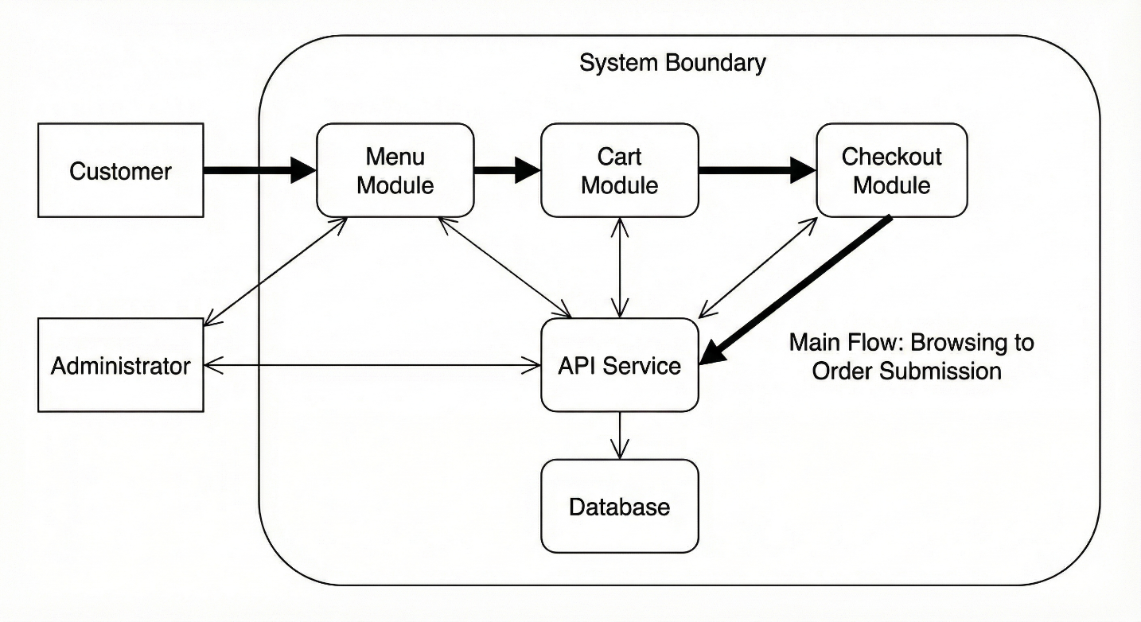

*Figure 1.1. System context diagram*

A context diagram that shows Customer and Administrator as primary roles, with the system boundary containing the Menu module, Cart module, Checkout module, API service, and Database. The diagram should also show the main flow from browsing to order submission.

## Objectives

The project objectives are defined in technical terms so they can be verified through implementation and testing.

First, the system must deliver a correct and usable ordering experience for customers. Correctness means the menu is presented consistently, filtering and search return expected results, cart quantities update reliably, and the total price remains accurate across repeated interactions. Usability means the navigation and ordering steps are clear and require minimal effort. Practical guidance for restaurant ordering systems emphasizes that search filters and clear navigation are core usability features that reduce friction and increase completion.

Second, the system must produce operationally complete order records. An order record must contain enough information for the restaurant to fulfill the order without needing additional clarification. The repository defines the intended order payload structure, including a list of ordered items and customer contact details, which establishes a concrete minimum for completeness.

Third, the system must be engineered for maintainability and extension. Although the first delivery focuses on customer ordering, the architecture should support a future administrative module for menu management and order management without requiring major redesign. This is consistent with the repository direction that identifies administrative capability as future work and exposes service endpoints that can support operational workflows.

To keep these objectives measurable, the project adopts a quality model mindset. ISO 25010 defines widely used product quality characteristics such as functional suitability, performance efficiency, usability, security, and maintainability, which provide a disciplined basis for non functional targets.

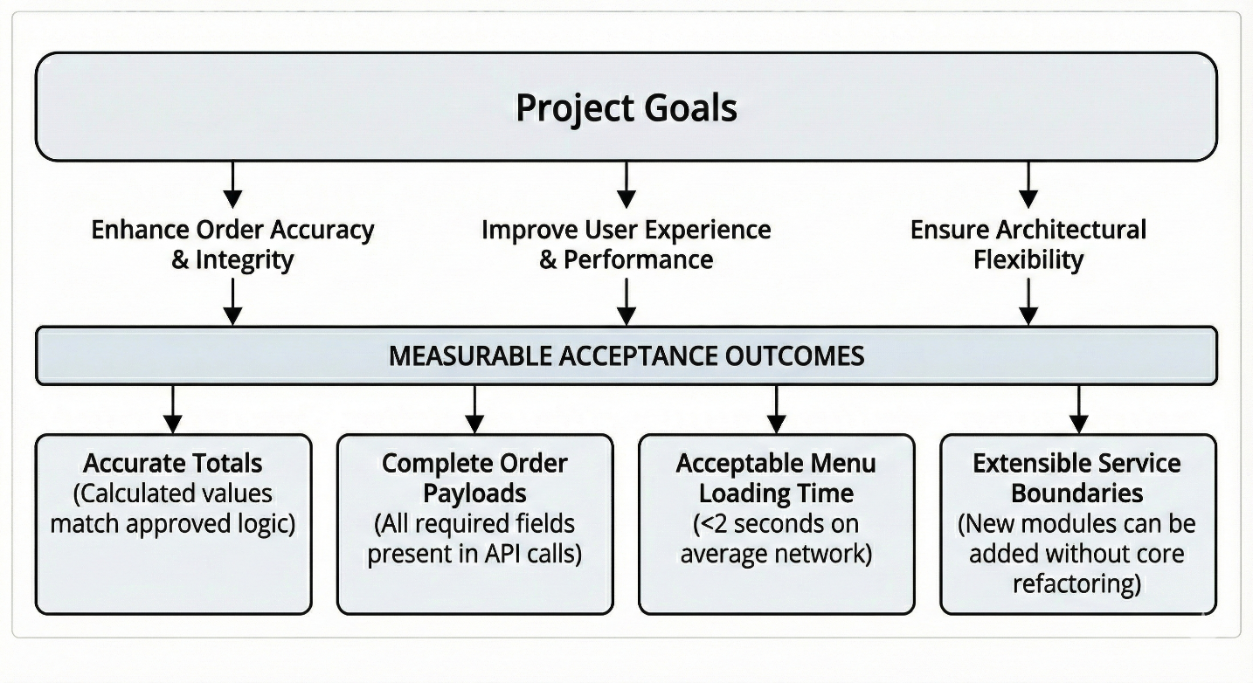

*Figure 1.2. Objective Map Linking Project Goals to Measurable Outcomes*

## Scope

This section defines what the system includes, what it excludes, and who uses it.

### In scope

The in scope customer functions include the following:

Menu discovery and browsing. Customers can view dishes with images, descriptions, prices, and category labels.

Filtering and search. Customers can filter dishes by category and search by dish name to quickly locate items.

Cart management. Customers can add items to the cart, remove items, adjust quantities, and see the total update automatically.

Checkout and order submission. Customers can enter required contact information and submit an order to the backend, where the order is stored and a confirmation is returned.

On the service side, the in scope technical functions include exposing API endpoints for retrieving dishes and creating orders, plus the supporting structure needed to validate and persist these requests. The repository documents these endpoints and provides example request and response formats, which define the baseline service contract for the website.

### Out of scope

The following items are intentionally out of scope for the current graduation delivery, but may be included as future work:

Online payment integration, advanced promotions, loyalty programs, and real time kitchen display operations.

Full administrative dashboard for staff, even though the API foundation is designed to support it.

Defining out of scope elements prevents scope creep and protects delivery quality, particularly in a graduation timeline where correctness and clarity are more important than feature count.

### Users

The primary users are:

Customer. Browses the menu and submits orders.

Administrator. Manages menu and reviews orders in future scope, and influences the data model and service design in the current scope.

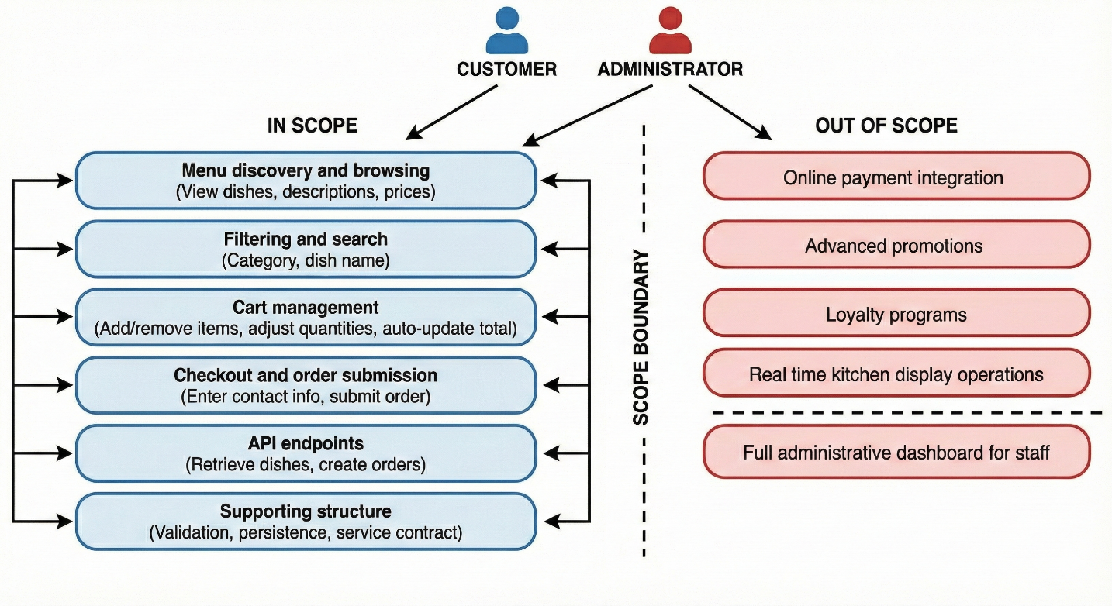

*Figure 1.3. System boundary diagram*

A scope boundary diagram that lists in scope features on one side and out of scope features on the other, and maps them to Customer and Administrator roles.

## Approach

This project adopts a layered web architecture that separates user interface responsibilities from server side logic and database persistence. This approach improves maintainability and makes the system easier to test because the contract between layers is explicit.

### User interface layer

The front end is built using React. React documentation describes the core idea that user interfaces are composed of small reusable pieces called components that can be combined into complete screens and applications. This is particularly appropriate for a restaurant ordering interface, where the menu is naturally represented as repeated dish cards, category controls, and cart line items. A component approach makes it easier to ensure consistent behavior, for example ensuring price formatting is identical across pages and ensuring quantity controls update totals in a predictable manner.

### Service layer

The backend is implemented using Express. Express documentation states that Express is a routing and middleware web framework with minimal functionality of its own and that an Express application is essentially a series of middleware functions. This matters because restaurant ordering requires consistent handling of cross cutting concerns such as input validation, request parsing, error handling, and cross origin configuration. Middleware provides a structured mechanism to apply those concerns consistently across endpoints, which reduces defects and makes future security and logging improvements easier to implement.

### Data layer

The database is MongoDB. MongoDB documentation emphasizes a flexible schema model where teams can iteratively improve the data model and add schema validation only to sections of documents that require stricter control. The database is MongoDB. MongoDB documentation emphasizes a flexible schema model where teams can iteratively improve the data model and add schema validation only to sections of documents that require stricter control.

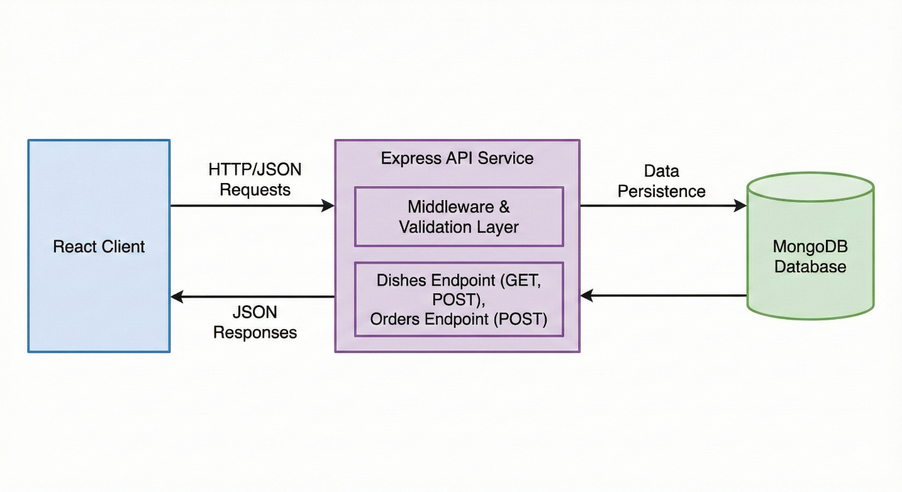

*Figure 1.4. High-level system architecture diagram.*

A high level architecture diagram that shows the React client calling the Express API, which applies middleware validation and persists data into MongoDB. The diagram should highlight the main endpoints for dishes and orders.

## Requirements method

A technical report should express requirements in a form that can be verified. This project adopts a requirements specification mindset consistent with recognized standards. IEEE 830 describes the content and qualities of a good software requirements specification, and IEEE notes that IEEE 830 1998 has been superseded by ISO IEC IEEE 29148. ISO IEC IEEE 29148 defines requirements engineering processes and the information items produced through those processes.

Following this approach, requirements are organized into:

Functional requirements, describing what the system must do for customers and for future administrators.

Data requirements, describing what must be stored and how records remain operationally complete.

Non functional requirements, describing quality targets using a recognized model such as ISO 25010.

This structure ensures the project remains testable. Every major requirement should be linked to at least one acceptance test scenario, and every acceptance test should map back to a requirement.

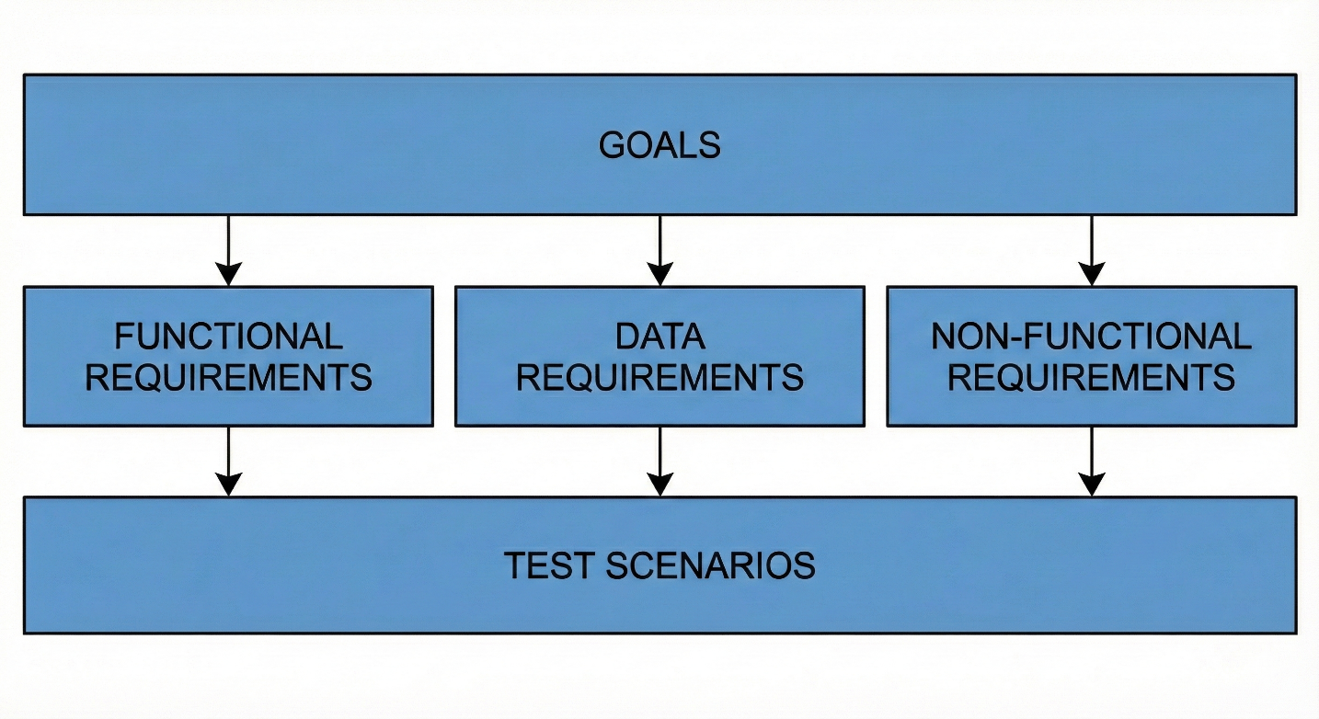

*Figure 1.5. Requirements hierarchy linking project goals to specific types of requirements and test scenarios.*

## Workflows

This section describes the business workflows that the system must support. These workflows translate requirements into concrete sequences of actions, and they become the foundation for activity diagrams and sequence diagrams in the design chapter.

### Customer ordering workflow

The customer journey begins when the customer enters the website and navigates to the menu. The customer browses categories, uses search if needed, and examines dish details such as price and description. The customer adds selected dishes to the cart, adjusts quantities, and verifies that the cart total reflects the chosen items. The customer proceeds to checkout, enters contact details, and submits the order. The backend returns confirmation information and stores the order so it can be retrieved and processed. This workflow is consistent with the repository defined customer features and the documented order creation payload.

### Restaurant intake workflow

When the backend receives an order request, it validates that required fields exist, that quantities and prices are valid types, and that customer contact information is present. The server should treat itself as the source of truth for validation. Once validated, the server persists the order in the database and returns a confirmation response. The repository defines a sample success response that includes an order identifier and creation timestamp, which is suitable for later tracking and retrieval.

### Menu maintenance workflow

Menu data changes are expected. New dishes may be introduced, prices may be updated, and availability may change. The system therefore requires a data model that supports change while preserving consistency. MongoDB data modeling guidance emphasizes iterative evolution with selective schema validation, which supports this operational reality: the model can evolve while still enforcing strict constraints on critical fields.

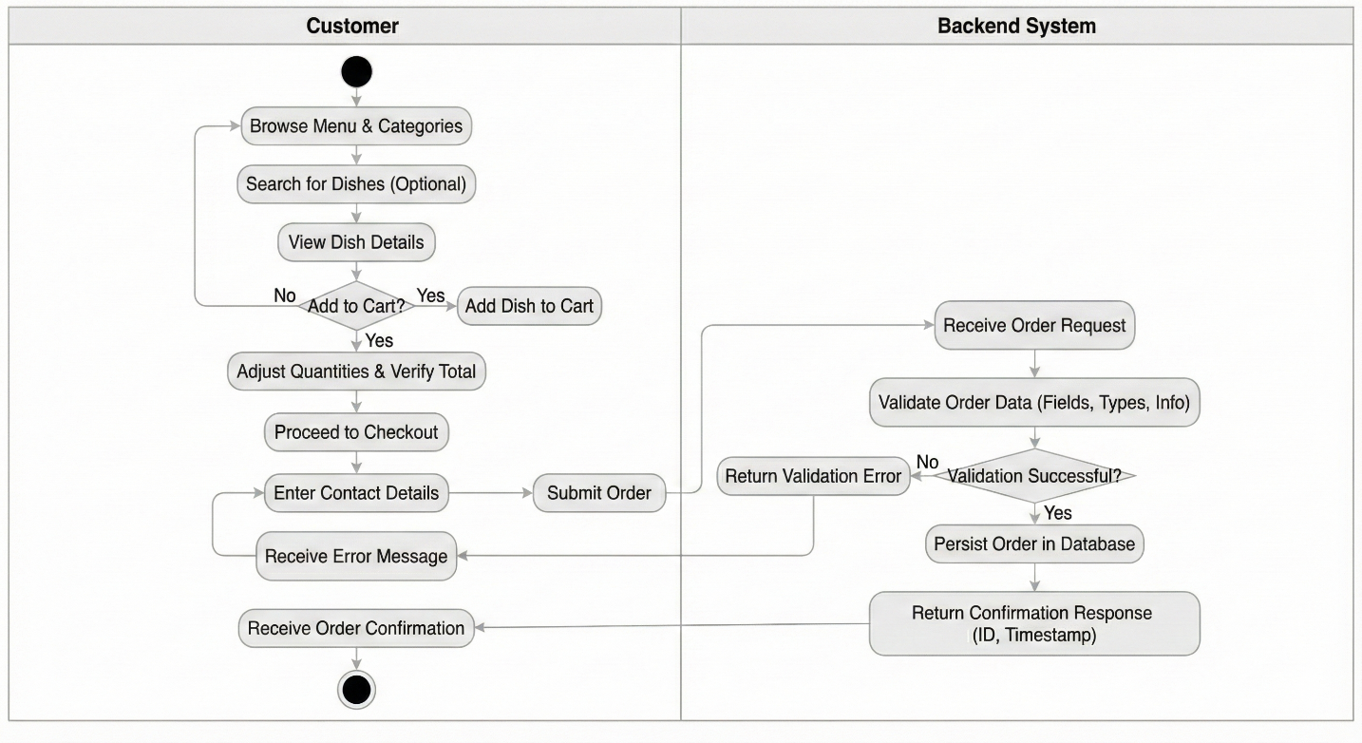

*Figure 1.6. End-to-end Ordering Workflow*

# SYSTEM ANALYSIS AND DESIGN

## Design Basis

### Core design goals

The system design is driven by five core goals.

Functional completeness for the customer journey

The minimum viable customer workflow must support menu exploration, item selection, cart adjustment, and order submission in a way that is consistent and repeatable. The repository lists these customer features explicitly, including menu viewing, searching and filtering by category, cart operations, and order placement.

Predictable system boundaries

The design must separate user interface concerns from business logic and persistence. This separation enables independent development and testing of each layer, and avoids embedding business rules inside the client where they can be bypassed.

Data correctness and traceability

Orders are treated as business records. Once created, an order must remain stable and auditable. This requires a data model that preserves order line items as historical snapshots of dish identity and price at the time of purchase.

Security by default, minimal exposure

Even when the scope focuses on ordering, the system must avoid common web security failures, especially broken access control and injection risks, as emphasized in OWASP Top 10 documentation.

Maintainability and future expansion

The current scope includes customer functions and documents future administrative capabilities such as managing dishes and orders. The design therefore treats administrative modules as planned extensions that can reuse the same API surface with stronger authorization controls.

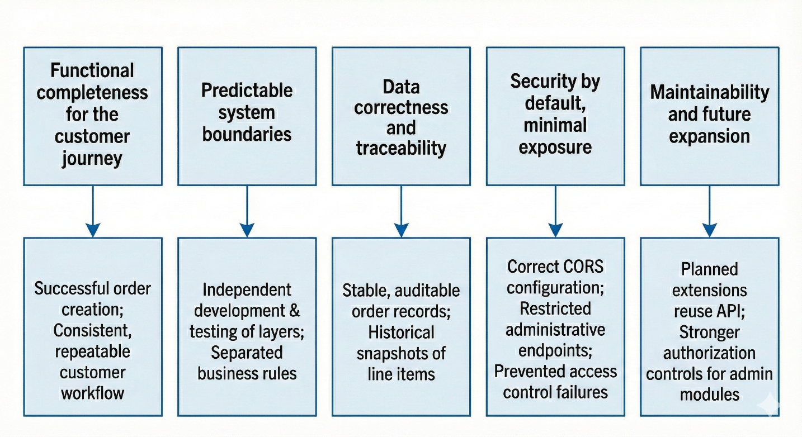

*Figure 2.1 Design goals map*

A diagram that maps each goal to measurable outcomes. For example: functional completeness maps to successful order creation; traceability maps to stable order records; security maps to correct CORS configuration and restricted administrative endpoints.

### Technology rationale

Frontend uses React, which encourages building interfaces as reusable components. React documentation explains that components are reusable UI elements and that a React application is composed of such components. This fits the menu domain, where many pages are composed of repeated visual units, such as dish cards, category tabs, cart items, and checkout forms.

Backend uses Express on Node.js. Express documentation states that Express is a routing and middleware web framework with minimal functionality of its own, and that an Express application is essentially a series of middleware function calls. This is a strong architectural match for building an API with consistent cross cutting controls such as input validation, CORS policy, authentication, and error handling.

Database uses MongoDB with a flexible schema model. MongoDB documentation describes the flexible schema approach and recommends applying schema validation to the parts of documents that require stricter control, enabling iterative development without sacrificing critical data consistency. This aligns with the restaurant menu domain, where dish metadata can evolve while key fields such as price and availability must remain strongly constrained.

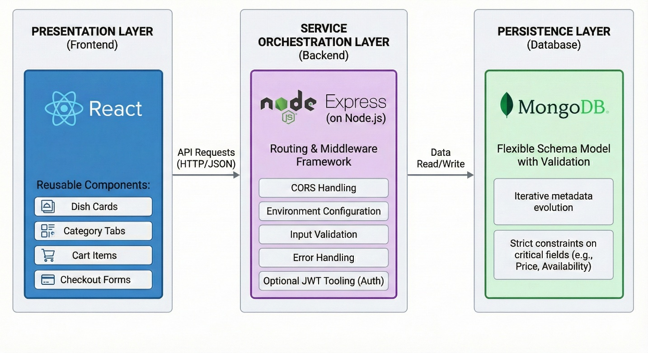

*Figure 2.2 Technology stack overview*

A diagram showing React for presentation, Express for service orchestration, and MongoDB for persistence. The figure should also list supporting libraries that the repository highlights, including CORS handling, environment configuration, and optional JWT tooling.

## Architectural Design

### Layered architecture

The system uses a classic layered architecture with clear responsibilities.

Presentation layer

The React single page application is responsible for rendering, navigation, and local interaction state. It loads dishes from the API, renders menu content, manages cart state through a dedicated client state module, and submits a complete order payload at checkout.

Service layer

The Express backend exposes REST style endpoints for dishes and orders, validates incoming requests, applies business rules, and persists data. The middleware oriented nature of Express supports modular request processing where concerns like parsing, validation, and CORS are not duplicated across endpoints.

Data layer

MongoDB stores categories, dishes, and orders. Schema validation and indexing are applied to keep operational data reliable and fast under common query patterns. MongoDB schema validation is explicitly designed to enforce data types and ranges even in flexible schemas.

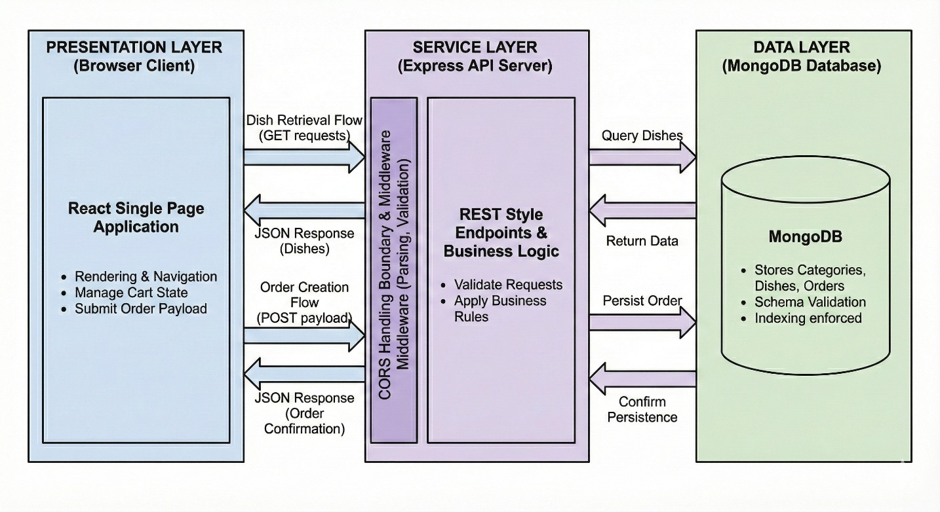

**Figure 2.3 System architecture**

A three layer diagram that shows the browser client, the API server, and the database. Add labeled arrows for dish retrieval and order creation flows. Indicate that CORS is handled at the API boundary.

### Deployment and environment boundaries

The system is expected to run in both development and production settings. In development, frontend and backend typically run on different local ports, which introduces a cross origin constraint. MDN describes CORS as an HTTP header based mechanism that allows a server to indicate which origins are permitted to load resources cross origin, and that browsers may send a preflight request to check permissions.

This makes CORS configuration a core part of the architecture rather than an afterthought. The backend must explicitly allow the frontend origin in development and production and must restrict it to known origins.

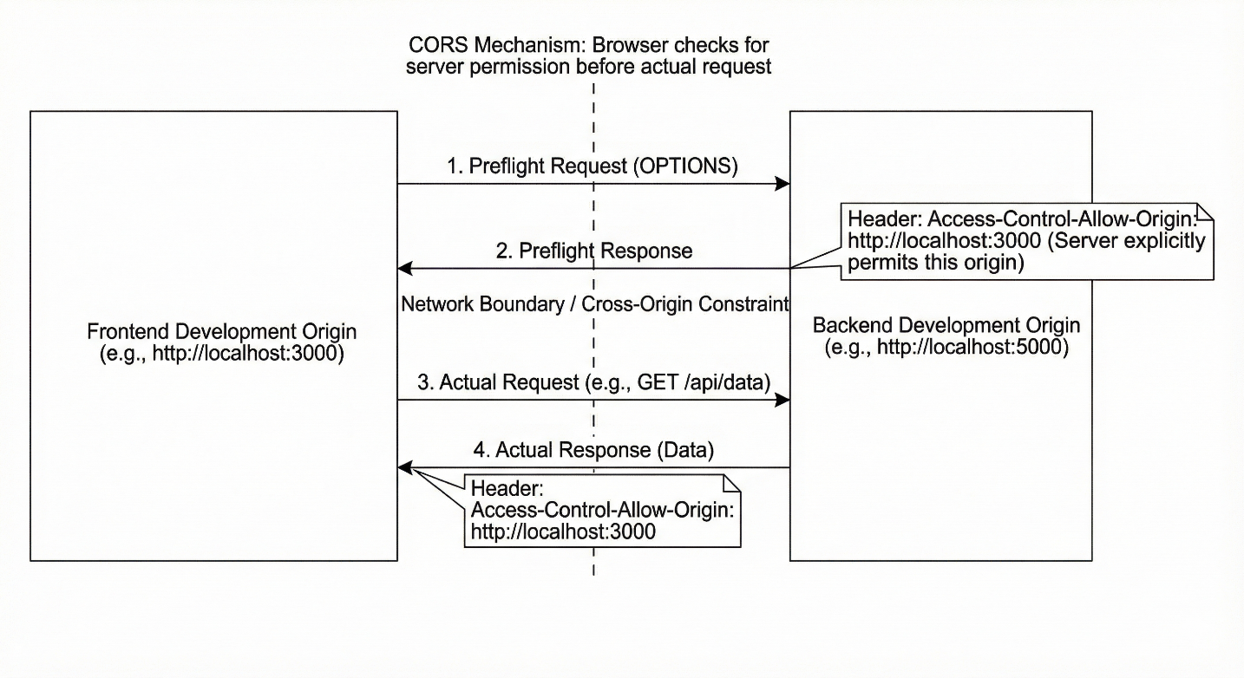

**Figure 2.4 Network boundary and CORS**

A diagram showing two origins in development, one for frontend and one for backend, and illustrating the preflight and actual request. Annotate the Access Control Allow Origin behavior conceptually, consistent with MDN.

### Directory structure as a design artifact

The repository documents a split into backend and frontend folders, with the frontend containing pages, reusable components, a cart context module, and an API service wrapper, while the backend includes server entry point and data seeding scripts.

This structure is part of the design because it enforces separation of concerns at a codebase level. The cart state module exists as a dedicated context component on the client side, supporting a predictable cart behavior across pages.

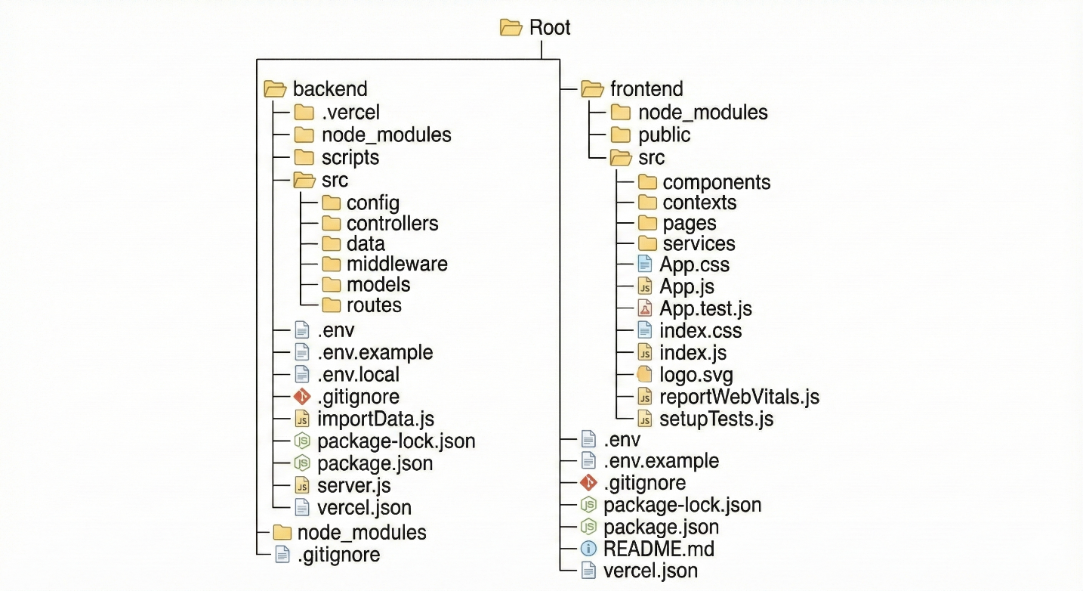

*Figure 2.5 Project structure*

A tree diagram derived from the repository structure that highlights frontend pages, shared components, cart context, and backend server entry and seeding script.

## Functional Design

### Customer functions

The customer features are defined as operational capabilities rather than only UI screens. The repository lists the customer set as: homepage, menu view, search and filter by categories such as fried, steamed, stir fried, noodles, soup, cart operations, checkout, and an about page.

These features are decomposed into function groups to support design traceability.

Menu services

* Load dish list
* Present dish content including image, description, and price
* Filter dishes by category
* Search dishes by name

Cart services

* Add dish to cart
* Remove dish from cart
* Update quantity
* Compute totals and present a deterministic summary

Checkout services

* Capture customer information
* Validate required fields at UI level for usability
* Submit order payload to server
* Display confirmation or error feedback

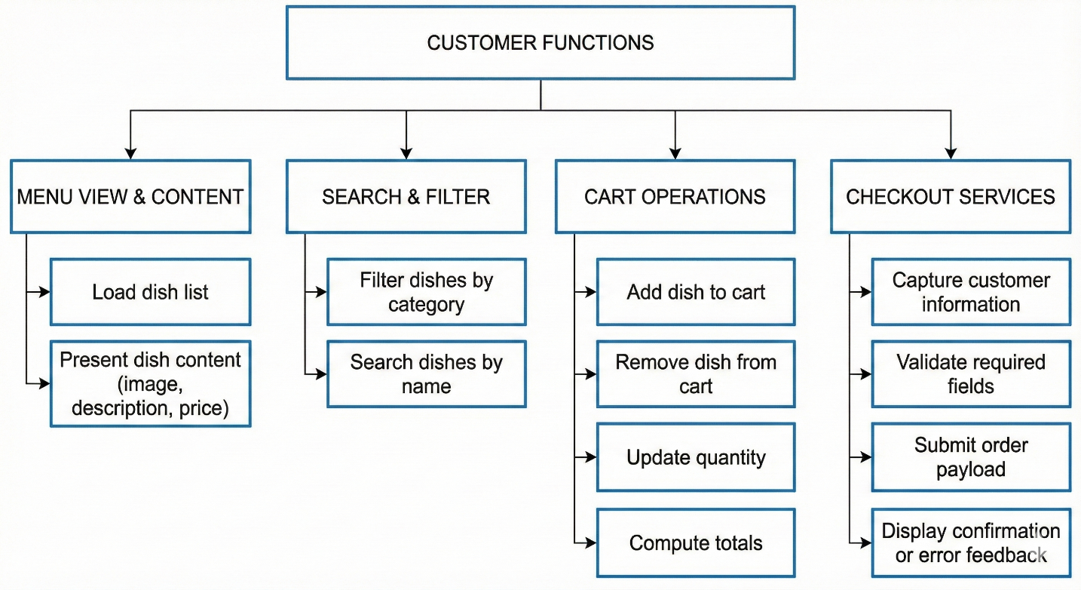

**Figure 2.6 Customer functional breakdown**

A hierarchical functional decomposition diagram. Level one includes menu, search, cart, and checkout. Level two lists operations such as add item, remove item, update quantity, and submit order.

### Administrator functions as future scope

The repository explicitly marks administrator features as future scope, including order management, dish management with CRUD, and customer management.

Although these are not required for the minimum customer scope, they influence the API design and the data model, because the system should later support administrative operations without breaking existing customers.

Administrative function groups

* Authenticate administrator identity
* Manage dishes with create, update, delete
* Manage categories
* Review and filter orders
* Update order lifecycle status in future extension

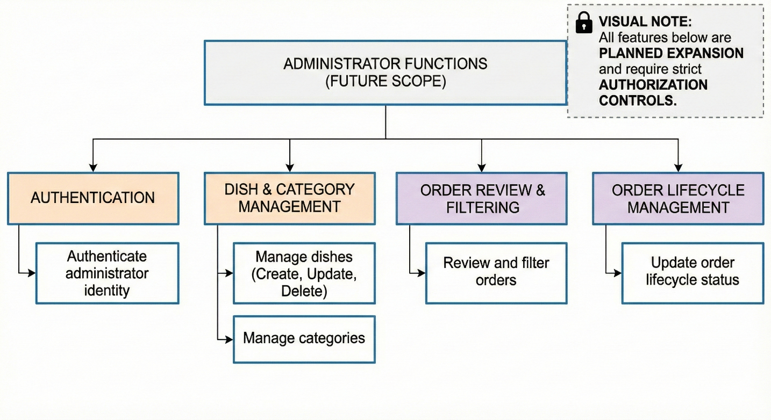

**Figure 2.7 Admin functional breakdown**

A similar decomposition diagram, with a visual note that these features are planned expansion and require authorization controls.

### Requirements classification

For a technical report, it is useful to classify requirements into functional and non functional categories. ISO IEC IEEE 29148 provides guidance for defining requirements and related information items in a consistent manner, and it is commonly used as a reference for disciplined requirements work.

Functional requirements

Describe what the system does, such as retrieving dishes and creating orders.

Non functional requirements

Describe how well it must perform, including security constraints, correctness, and maintainability.

Interface requirements

Describe data contracts at boundaries, especially the order request and response formats documented in the repository.

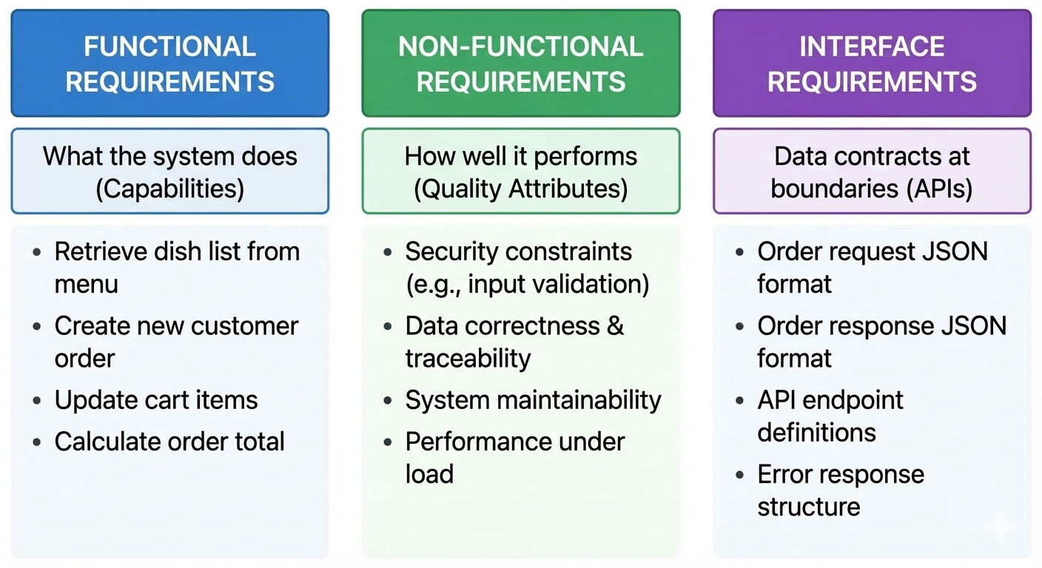

**Figure 2.8 Requirements classification**

A three column diagram showing functional, non functional, and interface requirements, with example items from the Henei Dimsum domain.

## Use Cases and Interaction Design

### Use case model

Use cases are defined per actor and bounded by the system.

Actors

Customer

Administrator, planned future actor

Customer use cases

View menu

Filter menu by category

Search for dish

Add dish to cart

Update cart

Checkout and submit order

These use cases align directly with the feature list in the repository and are therefore within scope.

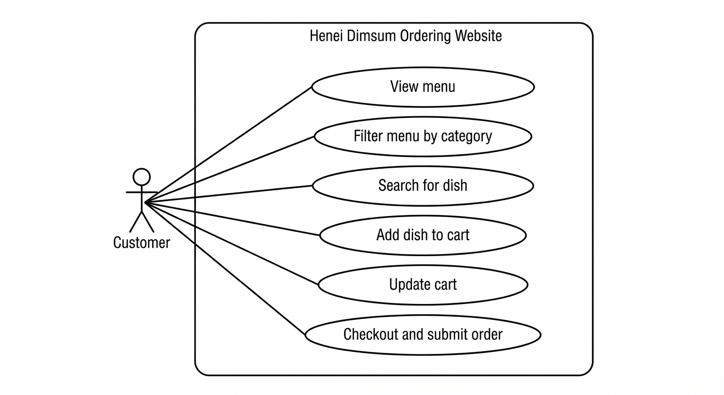

**Figure 2.9 Customer use case diagram**

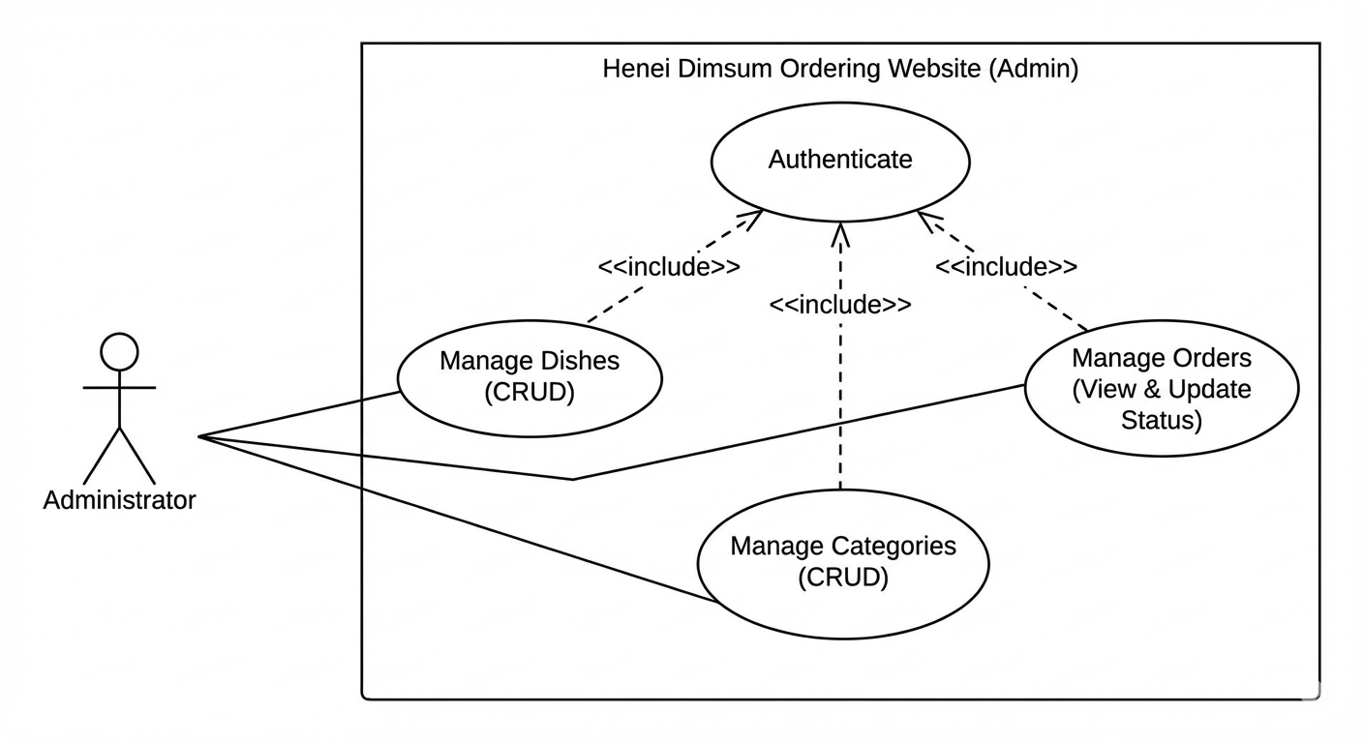

*Figure 2.10 Admin use case diagram*

A UML diagram with administrator actor and CRUD oriented use cases, with a dependency on authentication.

### Activity workflows

The activity view is used to express the operational logic of the system as a sequence of actions, decision points, and state transitions. In UML, an activity diagram represents the behavior of a process by describing the flow between actions. It is similar to a flowchart, but it can also capture alternate paths and, when required, parallel flows. The activity view is used to express the operational logic of the system as a sequence of actions, decision points, and state transitions. In UML, an activity diagram represents the behavior of a process by describing the flow between actions. It is similar to a flowchart, but it can also capture alternate paths and, when required, parallel flows.

Workflow A: Menu exploration

**Purpose.**

This workflow describes how a customer discovers dishes, narrows down options, and adds selected items to the cart. It is designed to support fast browsing while maintaining predictable behavior across filtering and searching actions.

**Entry conditions.**

The customer has access to the website and the service layer can provide the dish list. Categories are available and each dish is associated with exactly one category.

**Main flow.**

Step 1. The customer navigates to the Menu page through the primary navigation of the website.

Step 2. The system initializes the Menu page state and requests the dish list from the service layer.

Step 3. The system displays a loading state while awaiting the response, ensuring the interface communicates progress rather than appearing empty.

Step 4. After receiving the response, the system renders the dish list as a structured collection of dish cards. Each dish card presents the minimum decision information, including name, price, and a representative image.

Step 5. The customer optionally selects a category. The system applies the category condition and updates the visible dish list without reloading the entire page.

Step 6. The customer optionally enters a keyword into the search input. The system refines the current result set using the keyword, combining search with the active category filter when applicable.

Step 7. The system handles three possible result states in a deterministic manner.

First, if matches exist, the system shows the refined list.

Second, if no matches exist, the system shows a dedicated empty state that clearly indicates there are no results for the current conditions.

Third, if the request fails, the system shows an error state with a retry action.

Step 8. The customer adds one or more dishes to the cart. The system updates cart state immediately and provides visible confirmation, such as an updated cart indicator and updated subtotal in relevant views.

Step 9. The customer either continues browsing to add more dishes or proceeds to the cart page.

**Alternative flows and exceptions.**

If the dish list cannot be loaded due to a network or server error, the system enters an error state and provides a retry action. If the customer changes category or keyword while results are loading, the system preserves the most recent user intention and applies it after data is available to avoid inconsistent views.

**Exit conditions.**

The customer has either continued browsing with updated cart state or navigated to the cart for review. The cart remains persistent across navigation.

**Workflow B Cart management**

**Purpose.**

This workflow describes how a customer reviews selections, adjusts quantities, removes items, and confirms the order content before checkout.

**Entry conditions.**

The customer has at least one item in the cart or explicitly opens the cart page with an empty cart state.

**Main flow.**

Step 1. The customer opens the Cart page.

Step 2. The system loads the current cart state and renders line items. Each line item displays dish name, unit price, quantity controls, and line total.

Step 3. The system computes the cart subtotal as the sum of all line totals and renders the subtotal in a dedicated summary area.

Step 4. The customer updates quantities using increment and decrement controls.

Step 5. After each quantity change, the system recomputes the corresponding line total and the overall subtotal immediately. This immediate recomputation is critical for transparency and prevents cost ambiguity during ordering.

Step 6. The customer removes an item. The system deletes the item from the cart state and recomputes totals.

Step 7. If all items are removed, the system renders an empty cart state with a clear call to action that guides the customer back to the Menu page.

Step 8. When satisfied, the customer proceeds to checkout.

**Validation rules.**

The system enforces that quantity cannot be negative. If quantity is decreased below one, the system either prevents the action or converts it into a remove operation, depending on the chosen user experience rule. Totals are derived values and are never edited directly, ensuring that pricing display remains consistent with cart content.

**Exit conditions.**

The cart state reflects the final user selections and is ready for checkout.

**Workflow C Checkout and order submission**

**Purpose.**

This workflow converts a cart into a persistent order record and provides a confirmation response to the customer. It emphasizes validation at both client and server layers to protect data integrity.

**Entry conditions.**

The cart contains at least one valid line item and the customer has initiated checkout.

**Main flow.**

Step 1. The customer enters checkout information. The minimum dataset is defined to support restaurant fulfillment, such as customer name, phone number, and an optional note.

Step 2. The client performs basic validation, verifying that required fields are present and that cart content is not empty. The client surfaces validation feedback inline to reduce trial and error for the customer.

Step 3. The client submits an order request to the service layer, including customer information and the complete cart item list with quantities and unit prices.

Step 4. The server validates the payload. Server side validation is mandatory because requests can be malformed or manipulated outside the user interface. The server verifies required fields, item structure, quantity constraints, and value types.

Step 5. If validation fails, the server returns a client error response with a clear error model that the client can map to user facing messages.

Step 6. If validation succeeds, the server persists the order to the database. The stored order captures a snapshot of items, quantities, and prices at submission time, so that historical order integrity is preserved even if the menu changes later.

Step 7. The server returns an order confirmation response that includes at least an order identifier and a success status.

Step 8. The client displays a confirmation view and clears the cart state to prevent accidental duplicate submissions from repeated actions or navigation.

**Alternative flows and exceptions.**

If the network fails during submission, the client displays an error state and keeps the cart intact, allowing retry without data loss. If the server returns a validation error, the client highlights the corresponding fields and prevents clearing the cart so the customer can correct inputs.

**Exit conditions.**

A persistent order record exists in the database and the customer has received confirmation. The cart state is reset only after confirmed success.

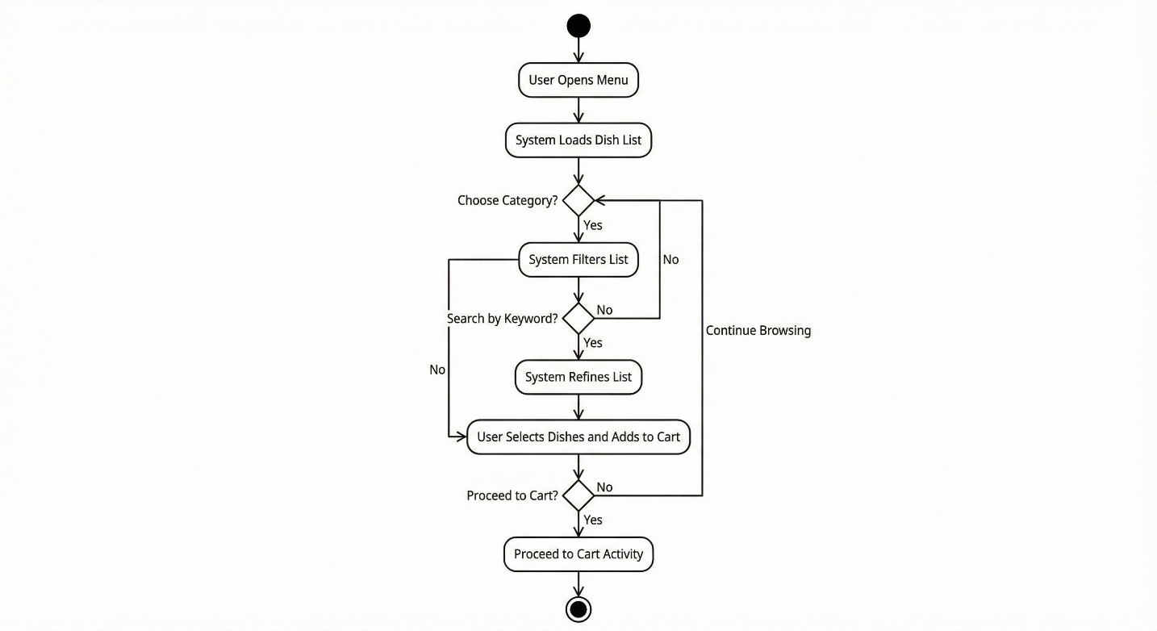

*Figure 2.11 Activity diagram for menu*

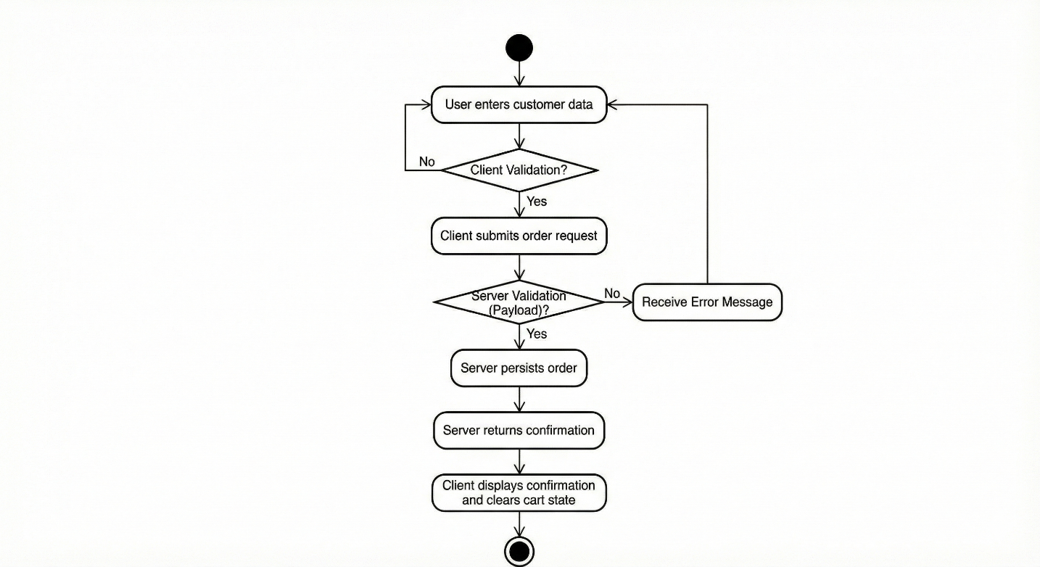

*Figure 2.12 Activity diagram for checkout*

### Sequence interactions

The sequence view defines how the client and server collaborate at runtime and is critical for implementation accuracy.

Sequence 1: Load dishes

Customer triggers menu page

React calls API service wrapper

Backend receives GET dishes request

Backend queries database

Backend returns dish list

React renders dish cards as reusable components

React component based UI design is consistent with the React documentation view that UI is built from components.

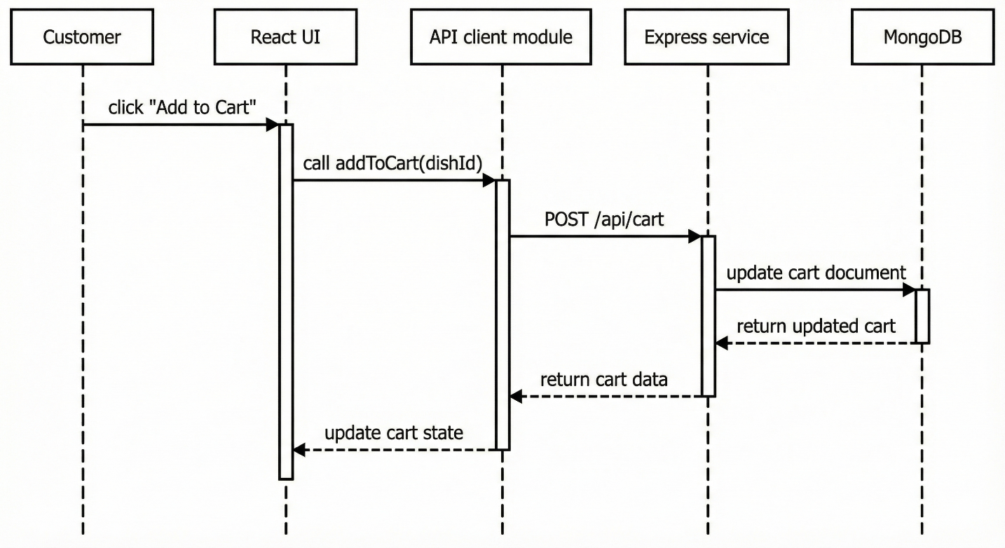

**Figure 2.13 Sequence diagram for dish list**

Lifelines: Customer, React UI, API client module, Express service, MongoDB. Messages: request dish list, query database, return list, render.

Sequence 2: Create order

Customer submits checkout form

React validates required fields

React submits order payload

Express parses body and validates schema

Express persists order

Express returns success response with order identifier and created time, consistent with repository example.

React displays confirmation

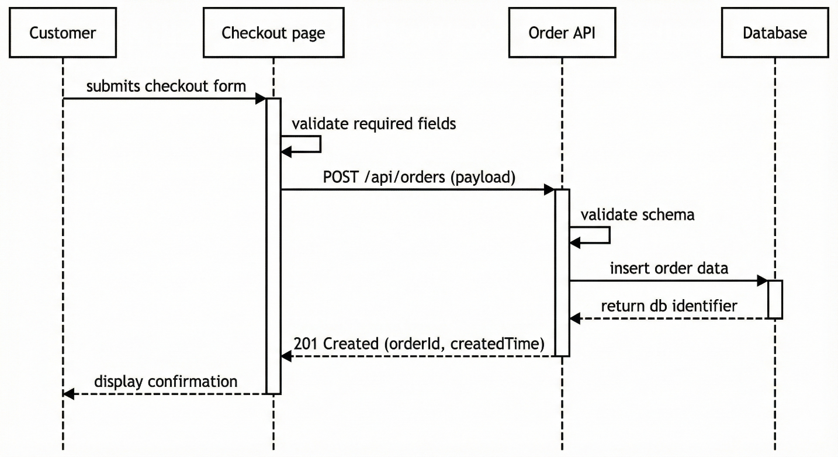

*Figure 2.14 Sequence diagram for order creation*

Lifelines: Customer, Checkout page, Order API, Database. Messages: create order, validate, insert, return response.

## Data Design

### Data modeling principles

MongoDB uses a flexible schema model where documents can evolve over time, and MongoDB documentation notes that teams can add schema validation only to the portions requiring stricter control. For a restaurant ordering system, this is a practical balance. Menu data may evolve, but the order record must remain stable.

Two key principles are applied.

Snapshot integrity for orders

When an order is created, each order item should store a snapshot of dish name and unit price. This prevents historical orders from changing if the dish name or price is updated later.

Controlled flexibility for dish metadata

Dishes may have optional metadata such as tags, cooking time, or allergens. These fields can be added without migration, while core fields remain strictly validated.

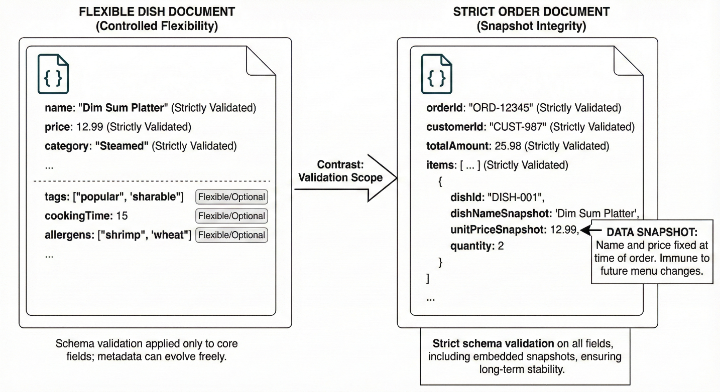

*Figure 2.15 Data modeling principles*

A diagram that compares two record types: flexible dish documents and strict order documents, highlighting where schema validation is applied.

### Collections and entities

The repository uses dishes and orders as core resources and exposes endpoints for them. Based on this, the logical entities are defined as follows.

Category

* Identifier
* Name
* Slug
* Active status

Dish

* Identifier
* Name
* Price
* Category reference
* Description
* Image path
* Tags
* Availability status

Order

* Identifier
* Items array
* Customer object
* Total price
* Created time
* Status for future extension

Order item

* Dish identifier
* Dish name snapshot
* Unit price snapshot
* Quantity

Customer

* Name
* Phone
* Note field

The order request example in the repository illustrates this structure, including items array, customer object with name and phone, and total price.

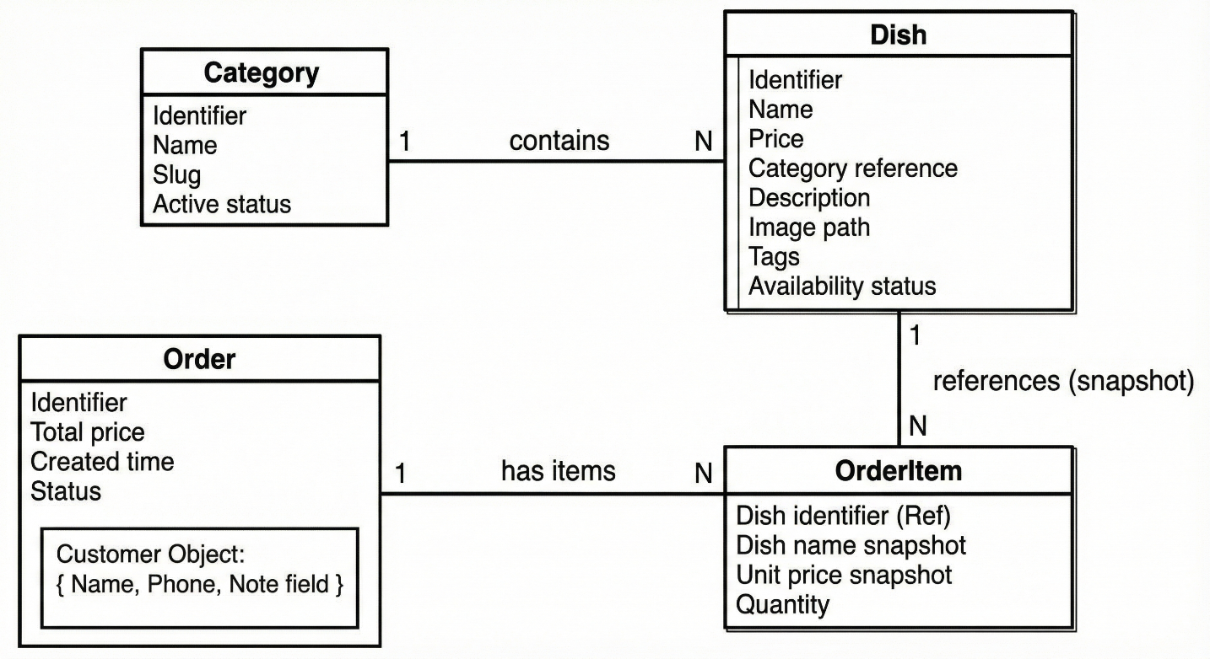

*Figure 2.16 Conceptual ER view*

A conceptual ER style diagram showing Category to Dish as one to many, and Order to Order item as one to many. Order item references Dish by identifier and stores snapshots.

### Schema validation and constraints

MongoDB schema validation allows rules such as type constraints and value ranges. The system should enforce the following constraints.

Dish constraints

Price must be a positive number

Name is required and non empty

Category reference is required

Availability is required

Order constraints

Items array must be non empty

Each item quantity must be a positive integer

Customer name and phone are required

Total price must be present and consistent with item totals

The rationale is operational: an order cannot be fulfilled without customer contact and without a consistent price total.

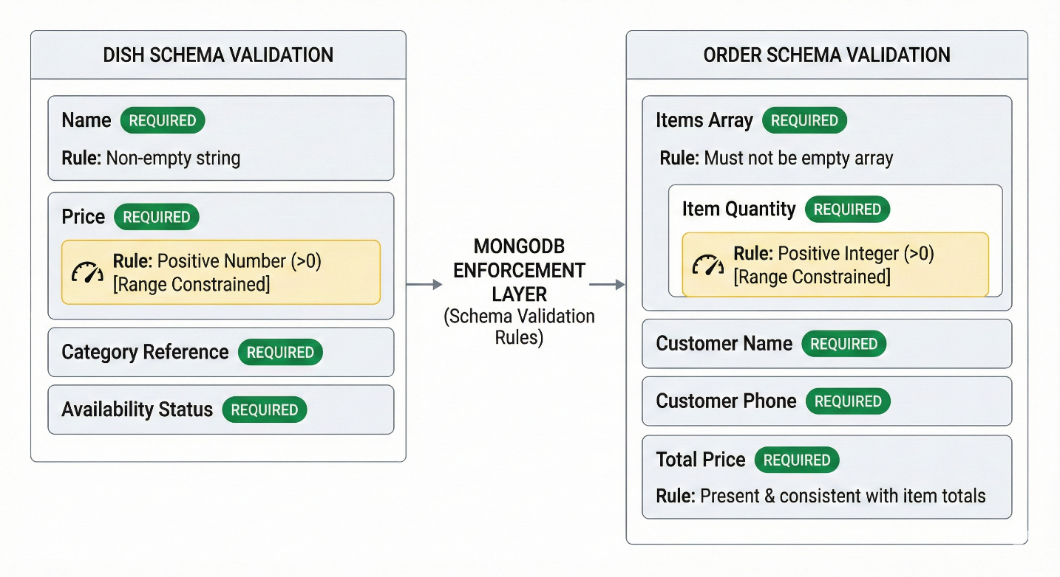

*Figure 2.17 Schema validation view*

A diagram showing which fields are required, optional, and validated. Mark price and quantity as range constrained.

### Indexing strategy

The most common read pattern is dish listing and filtering by category, plus search by dish name. The system should apply indexes to support these queries efficiently. MongoDB modeling guidance includes discussion of ensuring consistency and performance through suitable schema design and validation.

Recommended indexes

Dish category field

Dish name field, optionally a text index for search

Order created time for listing recent orders

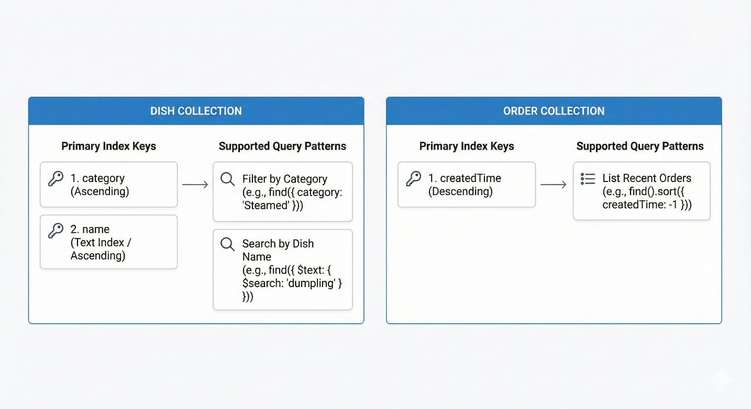

*Figure 2.18 Index plan*

A diagram listing each collection and its primary index keys, with the supported query pattern.

## API Design

### API style and semantics

The API follows a resource oriented approach. Correctness and client interoperability depend on consistent HTTP semantics. RFC 9110 defines status code classes and semantics, and MDN provides a consolidated reference for status codes based on RFC 9110.

Design rules

Use standard status codes consistently

Return JSON bodies for both success and error states

Use stable resource naming for dishes and orders

Avoid leaking internal error traces to the client

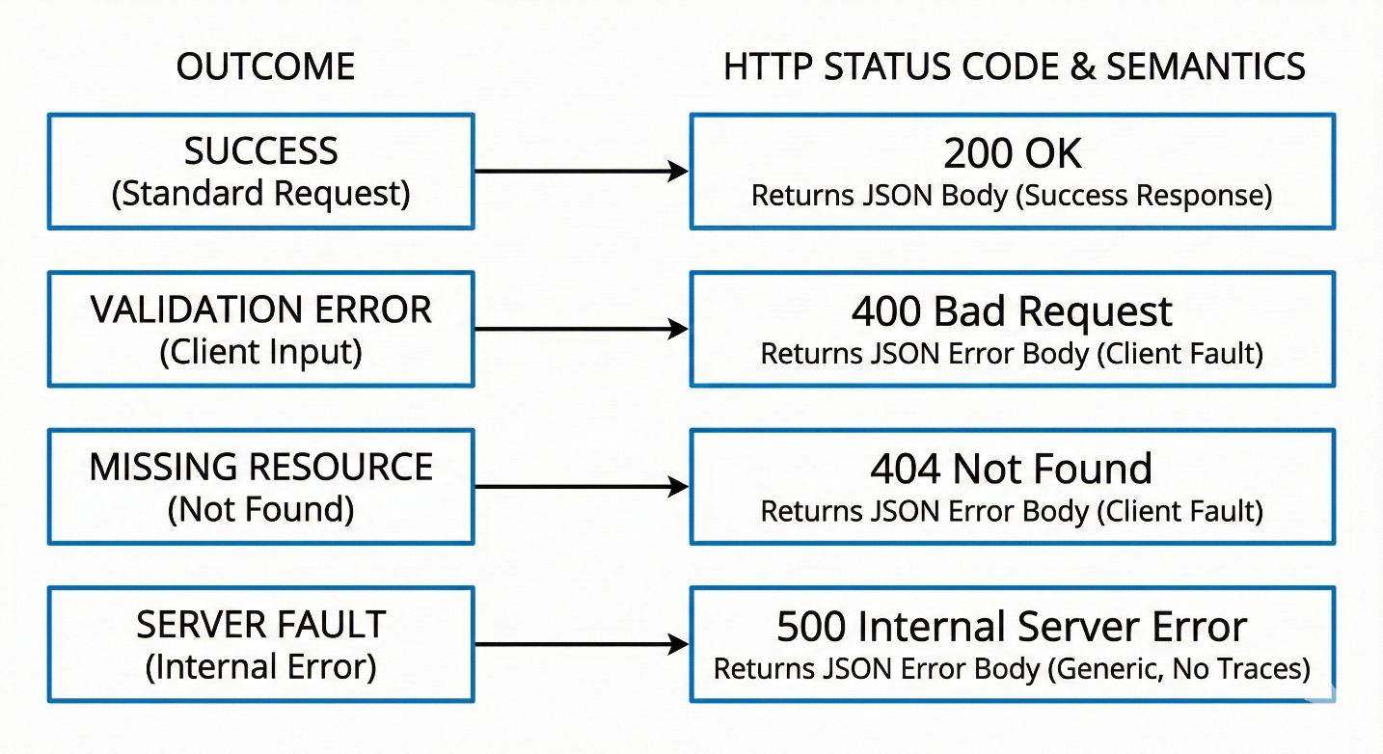

*Figure 2.19 API design rules*

A diagram that maps common outcomes to status codes, such as 200 for success, 400 for validation errors, 404 for missing resources, and 500 for server faults.

### Dishes endpoints

The repository lists dish endpoints for retrieving all dishes and performing CRUD operations for future admin scope.

Dish resource operations

Retrieve dish list

Create dish, admin

Update dish, admin

Delete dish, admin

For the current customer scope, the critical operation is retrieval. Filtering by category and searching by name can be implemented as query parameters, keeping the resource stable.

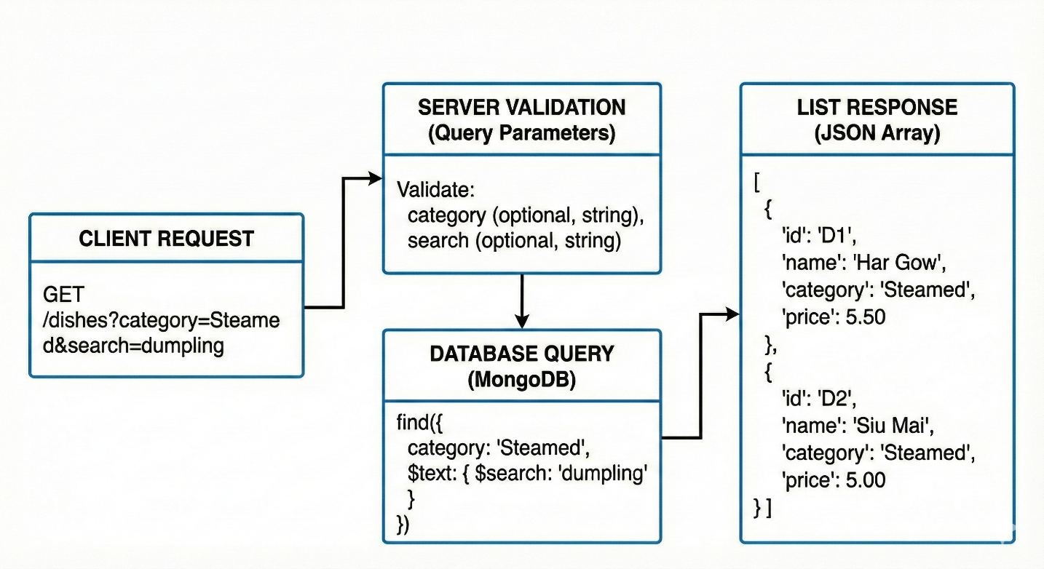

*Figure 2.20 Dish endpoint contract*

A diagram that shows client request, server validation of query parameters, database query, and list response.

### Orders endpoints

The repository lists the order creation endpoint and provides an example request payload and a success response that includes message, orderId, and order with createdAt.

Order resource operations

Create a new order

Retrieve an order by identifier

List all orders, mainly for admin and operations

Order creation contract

Items array containing dishId, name, price, quantity

Customer containing name, phone, and optional note

Total price

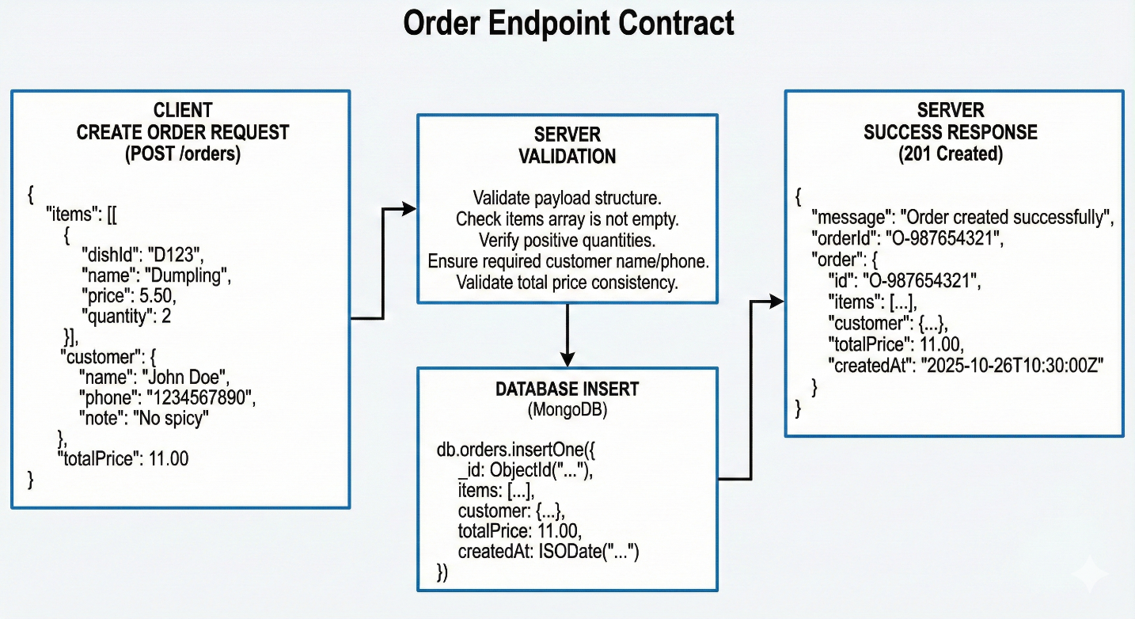

*Figure 2.21 Order endpoint contract*

A diagram that shows the create order request, server validation, database insert, and response with orderId and createdAt, consistent with the repository example.

### Error model and validation responses

A robust API must be explicit about errors. Validation errors should return a client error code and a body describing the problem. HTTP status code usage should follow standard semantics.

Examples of validation errors

Missing customer phone

Items array empty

Quantity not positive

Price not numeric

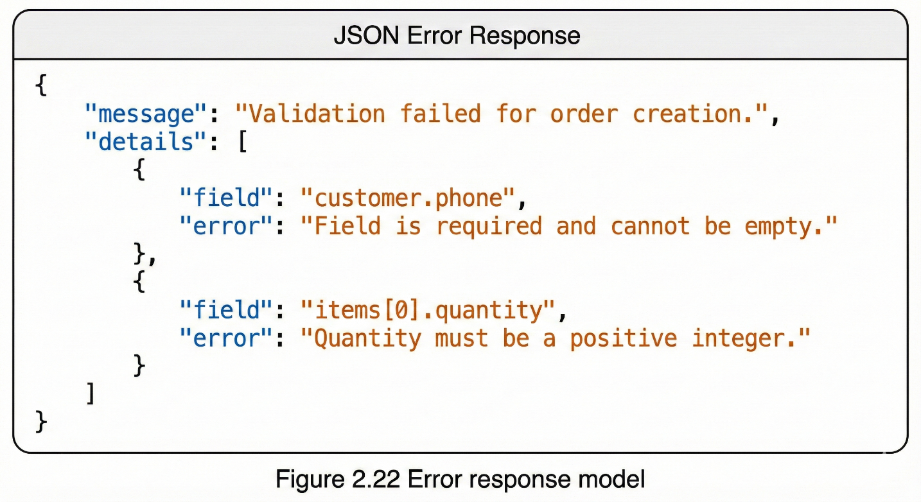

*Figure 2.22 Error response model*

A small diagram showing a standard error object layout, with fields such as message and details.

## Security and Quality Controls

### CORS and browser security boundary

CORS is a browser enforced boundary mechanism. MDN describes it as a header based mechanism and notes the preflight behavior for certain requests. The backend should implement a strict allow list policy that permits only the deployed frontend origin and the development origin.

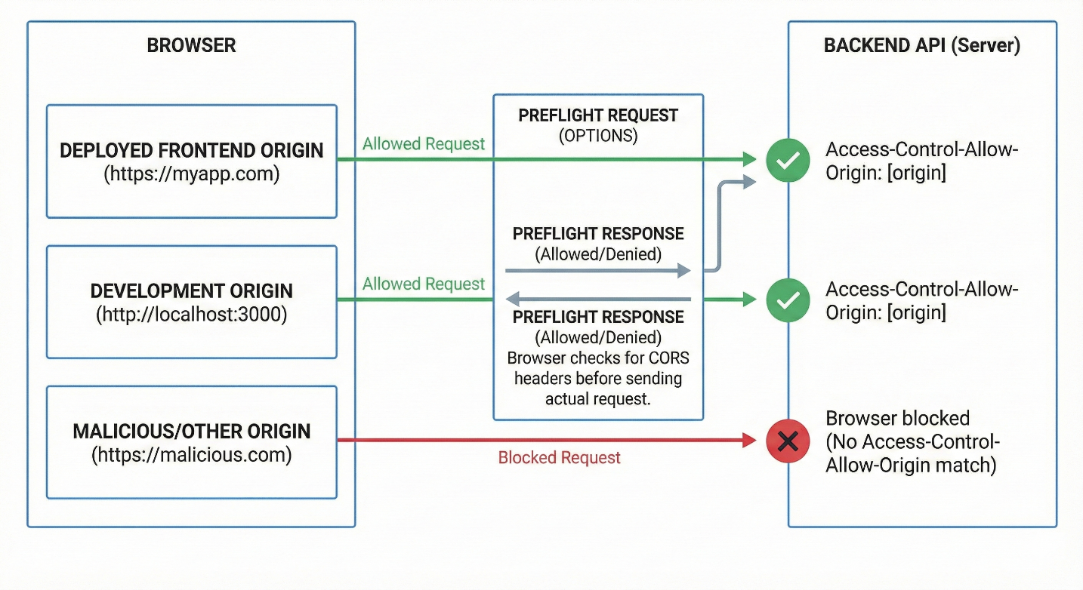

*Figure 2.23 CORS policy model*

A diagram illustrating allowed origins and blocked origins, plus the concept of preflight.

### Authentication readiness and JWT considerations

The repository includes optional use of jsonwebtoken and bcrypt tooling as preparation for future authentication. JWT is defined in RFC 7519 as a compact and URL safe means of representing claims transferred between parties.

In the current scope, authentication may not be required for customers, but it is important for administrators. The design should therefore include an authorization middleware conceptually, even if not fully implemented, so that administrative endpoints cannot be invoked by untrusted clients.

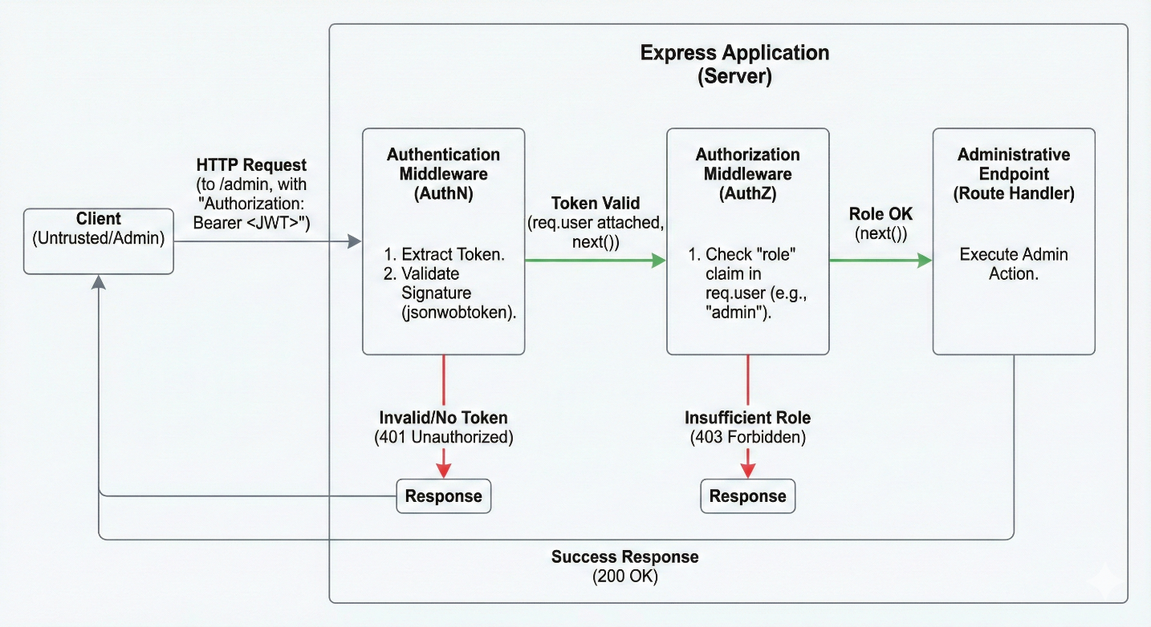

*Figure 2.24 Authentication extension design*

A diagram showing how requests to administrative endpoints pass through an authentication middleware that validates a token and then an authorization middleware that checks role, consistent with typical Express middleware composition.

### Threat awareness

OWASP Top 10 identifies broken access control as a leading risk category and provides common patterns of failure. For a restaurant ordering website, the most relevant threats include:

Unauthorized access to administrative endpoints

Injection style payload manipulation into query parameters or request bodies

Misconfigured CORS allowing untrusted origins

Information leakage through verbose error messages

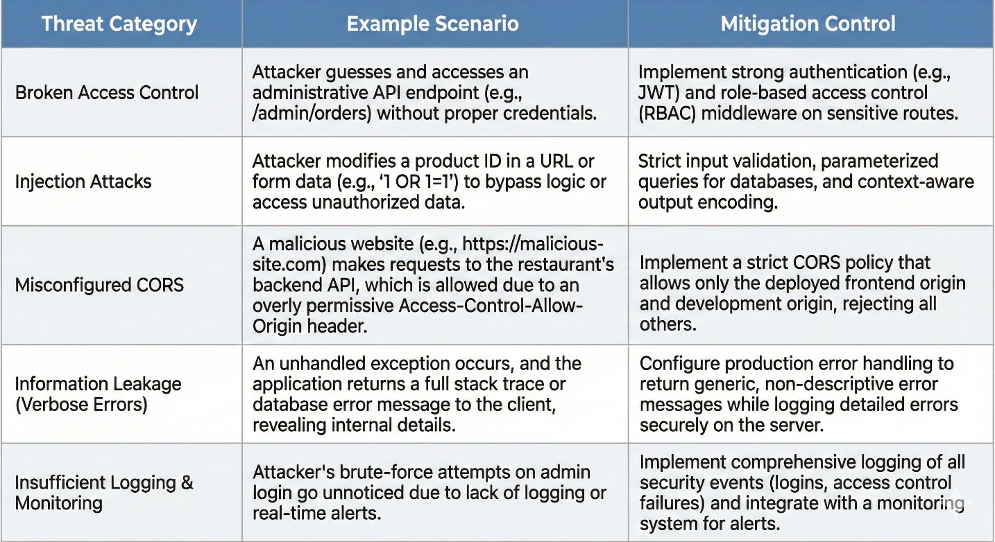

*Figure 2.25 Threat model summary*

A simple matrix listing threat category, example scenario, and mitigation control.

## UI Navigation and Menu Structure

This section defines the navigation design that will be implemented in the frontend, while keeping a clear separation from Chapter 3, which focuses on detailed screens. The repository indicates core pages including HomePage, MenuPage, CartPage, CheckoutPage, and AboutPage.

The menu structure of the thesis report should remain consistent with these page roles and avoid unnecessary complexity. A recommended thesis friendly menu is:

Front facing navigation

Home

Menu

Cart

Checkout

About

Administrative navigation, future scope

Admin dashboard

Dish management

Order management

Customer list

This matches the feature scope while allowing the thesis table of contents to remain clean and aligned with the actual system.

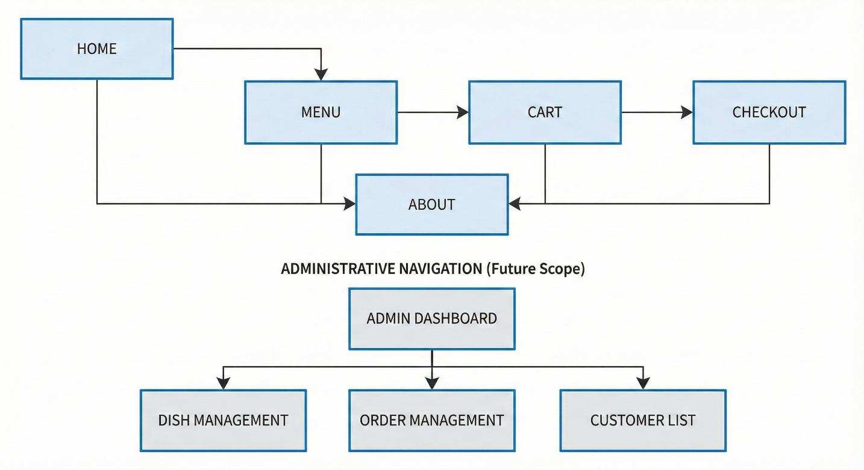

*Figure 2.26 Site map*

A site map diagram showing the page nodes and navigation edges: Home to Menu, Menu to Cart, Cart to Checkout, and global access to About.

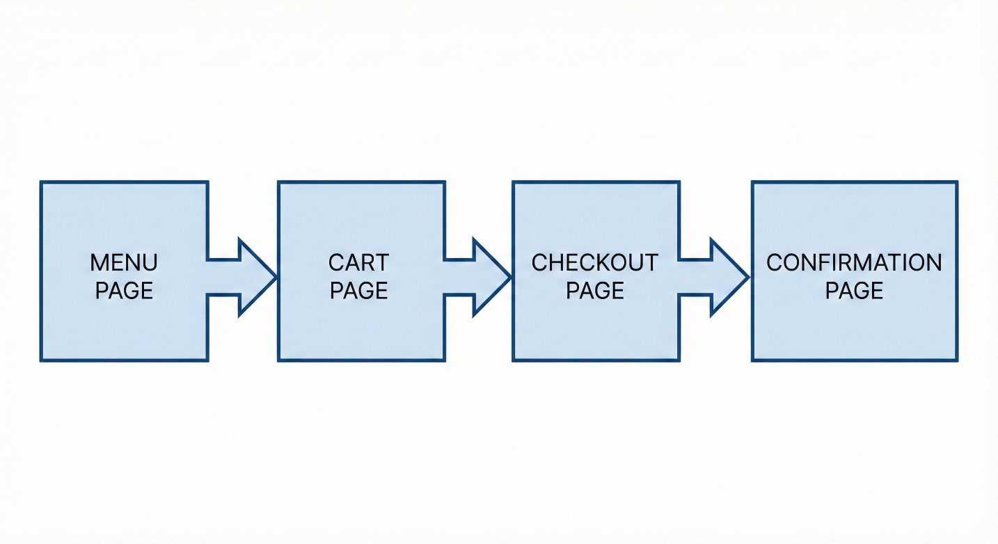

*Figure 2.27 Page flow*

A flow diagram showing the primary ordering funnel: Menu to Cart to Checkout to Confirmation.

# SYSTEM IMPLEMENTATION

This chapter presents the implementation of the Henei Dimsum restaurant website as an end to end working system. The objective is to demonstrate how the design decisions from Chapter 2 were translated into concrete software modules, runtime behaviors, and operational configurations. The implementation follows a layered structure that separates the user interface concerns from service logic and data persistence. The user interface is built as a React single page application composed of reusable components and stateful pages. React documentation describes components as independent reusable pieces that accept inputs through props and return elements that describe what should appear on the screen.

On the server side, the system uses an Express based application to expose a REST style interface for dishes and orders. Express uses middleware functions to control request processing and provides an error handling model where a centralized error handler is placed at the end of the middleware chain. Data is stored in MongoDB using collections with optional schema validation to enforce required structure and data types where necessary. MongoDB documentation emphasizes that schema validation can be used to create validation rules such as allowed data types and value ranges while retaining flexibility.

The remainder of this chapter is organized into four sections that match the implementation scope of the thesis: the project folder structure, the implemented features, the authentication readiness, and the configuration model including cross origin constraints and environment variables.

## Project folder structure

The implementation is organized to reflect the layered architecture at the code level. This is important for maintainability because it keeps the boundaries between presentation logic, business logic, and data access explicit. In practice, this separation also supports teamwork and future extension, because each layer can be evolved with minimal impact on the others.

### Client structure

The client directory contains the React application. The client is organized around two concepts: pages and reusable components.

Pages represent route level screens such as Home, Menu, Cart, Checkout, and About. Each page is responsible for coordinating data fetching, managing page state, and composing lower level components. Components represent reusable user interface elements such as navigation bar, category tabs, dish cards, cart rows, and order summary. This structure follows React’s recommended approach of breaking the interface into independent reusable pieces and thinking about each piece in isolation.

A typical client layout includes the following logical directories:

1. components

This directory contains reusable visual elements. Each component encapsulates a single responsibility, for example a dish card displays the image, name, price, and the add to cart action for one dish.

2. pages

This directory contains route level modules that compose many components. For example the Menu page composes category tabs, search input, and a grid of dish cards.

3. services

This directory contains the API client layer. The purpose is to separate network calls from page rendering so that pages remain focused on user interface composition. A common implementation uses Axios, which provides a promise based HTTP client for browser and server environments.

4. state

This directory contains shared state logic, especially for the cart. The cart must persist across route changes and should not reset when the user navigates between Menu and Cart pages. The shared state layer makes the cart a single source of truth.

5. assets

This directory stores static images and icons such as dish images and brand assets.

This client structure is intentionally designed to support a consistent ordering journey. The Menu page and Cart page are treated as primary flows and therefore reuse the same card and summary components to maintain visual consistency and reduce duplication.

### Server structure

The server directory contains the Express application. The server is organized to separate routing, business logic, data models, and cross cutting concerns such as validation and error handling.

A typical server layout includes:

1. routes

This directory defines endpoint routes and binds them to controllers. Routes focus on mapping HTTP methods and resource names to handler functions.

2. controllers

Controllers implement the request level orchestration. They validate input, call service functions, and reduce results into consistent responses. Controllers do not directly embed database query logic, because that reduces testability and makes code harder to evolve.

3. models

Models define database schemas and data access helpers. When MongoDB is used, models can define document shapes and constraints. In addition, MongoDB supports collection level schema validation using JSON Schema rules to enforce structure for critical documents.

4. middleware

This directory contains reusable middleware such as request validation, authentication readiness, and centralized error handling. Express documentation emphasizes that error handling is performed via middleware and that the default error handler is placed at the end of the middleware stack.

5. config

This directory contains configuration loading and environment variable parsing. It centralizes values such as database connection string and allowed client origins.

This structure makes it clear where each responsibility lives. Routes define the public contract. Controllers define the request behavior. Models define persistence behavior. Middleware defines cross cutting concerns. Config defines environment specific settings.

### Runtime scripts and developer workflow

The implementation includes scripts for development and production workflows. In development, the server benefits from automatic restart when files change. A common development tool is nodemon, which watches files and restarts the application when changes occur. This reduces iteration time during feature development and debugging.

The client development workflow uses a development server with hot reload so user interface updates can be observed immediately. The server development workflow uses automatic restart so API changes are reflected without manual restarts. Together these workflows enable a rapid feedback loop for full stack implementation.

## Customer and admin features

This section documents the features implemented in the system and how they work at the interaction level. The chapter prioritizes the customer ordering flow because it is the core value of the restaurant website. Administrative features are included as either implemented scope or structured readiness, depending on the actual project status.

### Customer features

The customer feature set is built around the ordering journey: discover menu, select items, review cart, submit order.

Menu browsing and category filtering

The Menu page loads dishes and allows users to filter by category. Categories such as steamed, fried, stir fried, noodles, and drinks are represented as selectable tabs or buttons. The filter operation updates the visible dish list without requiring a page reload, preserving the responsiveness expected from a single page application.

Keyword search

The Menu page includes a search input that filters dishes by name. The search behavior is designed to be forgiving and fast, supporting partial matches. When the search returns no results, the interface shows an empty state message that guides the user to clear the keyword or choose another category. This improves usability by preventing the user from misinterpreting an empty list as a loading failure.

Dish presentation and product clarity

Each dish is presented through a dish card component that contains the dish image, dish name, short description, and price. The card also includes an add to cart control. The purpose is to reduce cognitive load by keeping the key product information visible at the same time as the primary action.

Cart management

The cart is implemented as a persistent state object containing a list of items. Each item stores a dish identifier, dish name, unit price, quantity, and an image reference if needed. The Cart page displays each item in a row format with quantity controls and a remove action. When quantity changes, the total updates immediately. This behavior gives users confidence that they understand the order cost before submission.

Order summary

The cart and checkout pages include a summary section that displays subtotal and total. The total is computed as the sum of unit price times quantity for all items. The summary is derived from cart state and is never edited directly, which prevents inconsistencies.

Checkout and order submission

Checkout collects minimal customer information needed for fulfillment. A practical baseline includes customer name, phone number, and an optional note. The client performs basic validation, such as non empty required fields, and then submits the order to the server. After a successful response, the interface shows an order confirmation message and clears the cart to prevent accidental duplicate orders.

### Administrator features and readiness

In many restaurant systems, menu maintenance is a key administrative task because menu items change over time due to availability and pricing. The system design supports administrative capabilities such as creating, editing, and removing dishes, as well as managing categories.

If administrative features are implemented, they follow this model:

1. Protected routes for administrative pages

2. Administrative controls for dish creation and update

3. Validation on the server side to prevent invalid menu items

4. Basic auditing in logs for create and update operations

If administrative features are not fully implemented, the system still maintains readiness by having a clear role model in the user schema and clear route boundaries that can be protected later. This readiness is important for thesis credibility because it demonstrates that the design anticipates realistic restaurant operations even if the current scope prioritizes customer ordering.

### Data correctness and user feedback behavior

Across all user flows, feedback states are implemented explicitly:

Loading state

When data is being fetched, the interface shows a loading indicator rather than displaying a blank page. This reduces confusion and improves perceived reliability.

Error state

When a network request fails, the interface shows an error message with a recovery action such as retry. This is critical because failures can occur due to connectivity, server downtime, or configuration issues.

Empty state

When a filter or search yields no results, the interface shows a dedicated empty state with guidance. This is distinct from an error state and prevents users from interpreting an empty list as a failure.

These states are implemented as reusable components so that behavior and styling remain consistent across pages.

## Authentication and authorization (JWT)\

This section describes how authentication is implemented or prepared, focusing on JSON Web Token based authorization for protected operations. JSON Web Token is standardized by RFC 7519, which defines it as a compact URL safe means of representing claims transferred between two parties.

Even when the customer ordering workflow is the primary focus, authentication becomes relevant for two reasons. First, administrative actions such as creating or editing dishes must be restricted. Second, operational stability requires a clear definition of who can modify persistent data.

### Token model

The token carries claims that represent the user identity and role. The role claim distinguishes a customer from an administrator. When the server signs the token, the client can present it in subsequent requests as proof of authentication, and the server can verify it before allowing protected actions.

The system uses a secret key to sign tokens in a symmetric signature model. The secret key is stored as an environment variable and never hard coded in the repository. This reduces the risk of accidental disclosure.

### Authorization enforcement

Authorization is enforced through middleware in the server. The middleware performs three steps:

Step one: Extract token from the request headers.

Step two: Verify token signature and decode claims. If verification fails, return an unauthorized response.

Step three: Check role claim against the required role for the endpoint. If the role is insufficient, return a forbidden response.

This pattern is consistent with the Express middleware model where request processing is composed of a chain of functions and error handling is centralized.

### Security oriented error handling

When authentication fails, the server returns a minimal error message. In production, the server does not include internal stack traces in responses. Express documentation notes that stack traces are not included in production responses, which supports safe error behavior.

The client uses these responses to display user friendly feedback. For example, if an admin page is accessed without authorization, the interface can redirect the user to a login page or show an access denied message.

## CORS configuration and environment variables

This section describes environment separation and the implementation of cross origin constraints. These concerns are critical for real deployments because front end and back end may run on different origins.

### Cross origin boundary

Browsers enforce a security model that restricts cross origin requests. Cross Origin Resource Sharing is an HTTP header based mechanism that allows a server to indicate which origins are permitted to access resources. MDN explains that CORS is implemented through response headers and may involve a preflight request that checks whether the server permits the actual request.

The implementation uses an allow list strategy. Only the configured front end origin is permitted. This ensures that the API does not respond with permissive headers that would allow arbitrary browser based origins. The Access Control Allow Origin response header indicates whether the response can be shared with requesting code from the given origin.

Preflight requests are handled correctly by permitting required methods and headers. In preflight responses, the server may include Access Control Allow Headers to indicate which headers can be used during the actual request.

### Environment variables and configuration loading

The system uses environment variables to separate configuration from code. This allows the same code to run in development and production without modification. The dotenv package is commonly used to load variables from a file into process environment values during local development. The npm documentation for dotenv describes it as a module that loads environment variables from a file into process environment.

Typical variables include:

Database connection string: This variable points to the MongoDB cluster or local database instance.

Client origin: This variable specifies the allowed origin for CORS.

Token signing secret: This variable stores the JWT signing secret.

Server port: This variable specifies the port the API listens on.

In production, these values are configured in the hosting environment rather than in a local file. The application reads them at startup and configures database connections and security policies accordingly.

### Practical configuration discipline

Two implementation rules are enforced:

Rule one: No secrets are committed to the repository. All secrets are stored in environment variables.

Rule two: Configuration is centralized in one module so that there is a single source of truth for runtime settings. This avoids inconsistent behavior between different server files and reduces operational risk during deployment.

# DEPLOYMENT AND OPERATIONS

This chapter describes how the Henei Dimsum website is prepared for release, deployed across environments, and operated in a controlled manner. The goal is to ensure that the system can run reliably outside the development machine, maintain consistent configuration across environments, and support routine operational tasks such as monitoring, troubleshooting, and safe updates. The deployment model follows the layered structure described in earlier chapters, meaning the user interface, service layer, and data layer can be deployed and managed independently while still behaving as a single product.

A key principle in this chapter is configuration separation. The same source code should run in different environments, while sensitive values and environment specific settings are provided at runtime through environment variables rather than being hard coded. This approach is aligned with Node runtime practice where applications read configuration from the process environment, and it is also aligned with common tooling such as dotenv for local development configuration.

## Development environment

The project uses two operational environments in practice.

Development environment is used for rapid iteration. It focuses on fast feedback, readable logs, and the ability to restart services quickly after code changes. Local development commonly uses a local environment file to store non secret development values, and dotenv loads these values into the Node process environment at runtime.

Production environment is used for real users. It focuses on stability, controlled releases, strict security defaults, and predictable configuration. In production, environment variables are configured through the hosting platform rather than a local file. For deployments on Vercel, environment variables are managed at the project level, can be separated by environment such as development, preview, and production, and can also be pulled into local development using platform tooling.

The environment model is expressed through a small set of configuration variables.

Database connection variable: This value points the service layer to the MongoDB cluster. The connection string format is defined by MongoDB documentation, and it is obtained from the Atlas connection flow.

Client origin variable: This value restricts which browser origin is permitted to call the service layer from the user interface deployment, supporting a controlled cross origin boundary.

Service port variable: This value specifies the listening port for the service process in development or in a container based deployment model.

Token secret variable if administrative authorization is enabled: This value signs and verifies tokens and must be treated as a secret.

Operational mode variable: This value indicates production mode, which affects logging verbosity and error response behavior.

In implementation, the system loads configuration at startup and fails fast when required configuration is missing. Failing fast is operationally preferable because it prevents the service from running in an unknown or insecure configuration.

## Frontend deployment

The user interface is deployed as a static web application produced by a build step. The build produces optimized assets that can be served efficiently through a content delivery network. The deployment strategy is designed to support repeatable builds and simple rollbacks by tying each release to a specific source control revision.

A practical deployment approach is to connect the repository to a hosting platform that supports automatic builds on commit. In this workflow, each commit to a branch can generate a preview deployment, and the main branch can generate a production deployment. Vercel supports this model and provides explicit environment variable handling for development, preview, and production deployments.

The frontend deployment includes three operational concerns.

Build time configuration: Some variables must be available at build time, such as the base URL of the service layer. Vercel documents that environment variables can be attached to specific environments, enabling different base URLs for preview and production.

Runtime behavior across environments: Preview builds allow testing new features against a non production service endpoint. Production builds target the stable service endpoint and stable database. This separation reduces risk by preventing unfinished changes from affecting real users.

Consistency between local and hosted environments: Vercel provides a mechanism to pull environment variables into a local environment file for development workflows, which reduces configuration drift between local and hosted environments.

In operational terms, the frontend deployment is considered successful when the following checks pass.

The home page loads without console errors

The menu page can fetch dishes successfully

Cart operations work entirely on the client

Checkout can submit an order and receive confirmation

Network requests show correct target origin and do not fail due to cross origin restrictions

These checks can be executed as a short post deployment smoke test, either manually or through a lightweight automated workflow.

## Database deployment

The database layer is deployed using MongoDB Atlas as a managed service. The primary reason to use a managed database is operational simplicity, including high availability options, predictable connectivity, and tooling support for access control. Atlas requires explicit network access control through an IP access list, meaning only clients from approved IP addresses or CIDR ranges can connect.

### Cluster provisioning and connectivity

After creating a cluster, the project configures a database user and obtains a connection string suitable for application drivers. MongoDB documentation describes the steps to connect to an Atlas cluster and highlights that the client must be on the IP access list.

A common operational failure is a connection attempt from an IP address that is not permitted. MongoDB troubleshooting guidance explicitly lists this condition and emphasizes that client connections are allowed only from IP addresses and CIDR ranges in the IP access list.

### Network access control

The IP access list is configured to include the service deployment environment. In a simple development workflow, the developer adds the current public IP address so the local service can connect. In a production workflow, the service environment must be included, typically by allowing the fixed egress IP range of the hosting environment or by using a private networking option where available.

MongoDB Atlas documentation provides a concrete procedure to add entries to the IP access list, including single IP addresses and CIDR ranges.

### Data initialization and operational readiness

Before production use, the project initializes core collections, especially categories and dishes. A controlled initialization reduces early operational risk by ensuring that the menu is available and the user interface can render meaningful content immediately.

The project also prepares indexes that support menu filtering and search patterns. Indexing should be applied before exposure to user traffic so that query performance remains predictable as data grows.

## Service deployment and runtime operations

The service layer is implemented with Express and is deployed to a Node runtime environment that supports long running processes or serverless request handlers, depending on platform choice. Regardless of hosting model, the service must provide consistent request processing, safe error handling, and stable connectivity to the Atlas cluster.

### Production readiness of the service

Express provides guidance for production best practices related to security and performance. On the security side, Express recommends practices such as using TLS, avoiding vulnerable versions, and adopting defensive middleware for security headers. On the performance side, Express describes production practices such as proper error propagation through the middleware chain and general performance oriented guidance.

In the implemented project, production readiness is enforced through the following controls.

Central error handling: The service uses a centralized error handler so that responses are consistent and internal details are not leaked. This is aligned with Express guidance on error propagation and middleware design.

Strict input validation: Order creation validates required fields, item structure, and quantity constraints. Validation errors return a client error response with actionable information.

Least privilege database access: The service uses a dedicated database user, and credentials are stored in environment variables rather than source code.

Controlled cross origin access: The service configures allowed origins so only the deployed user interface origin can call the API from a browser context.

### Configuration handling

The service reads configuration from the environment at startup. In local development this can be loaded from a local environment file using dotenv, which loads environment variables from a file into the process environment.

In hosted environments, variables are configured via the platform settings. In the Vercel model, environment variables are managed by environment type and can be applied differently for preview and production deployments.

This model prevents secret leakage, improves portability, and reduces accidental configuration drift.

### Logging and troubleshooting workflow

Operational logging focuses on request outcomes and failure modes. At minimum, logs should capture the endpoint, status code class, latency category, and a correlation identifier for tracing. Error logs should capture error type and high level context, without including sensitive payload content.

When connectivity issues arise, the troubleshooting workflow proceeds in a deterministic sequence.

First confirm the database client IP is on the Atlas IP access list, since Atlas blocks connections by default unless the IP is permitted. Then confirm database user credentials are correct, as Atlas requires authentication with a database user.  
Then confirm the connection string used by the service matches the driver format and target cluster. Finally confirm the service environment variables match the intended environment, because misconfigured variables can point to the wrong database or wrong origin policy.

This systematic workflow reduces downtime and avoids random trial and error debugging under deadline pressure.

# TESTING AND QUALITY ASSURANCE

This chapter presents the testing and quality assurance activities applied to the Henei Dimsum restaurant website. The purpose is to demonstrate that the delivered system is not only functional, but also reliable under typical usage conditions, predictable in error scenarios, and maintainable for future iterations. The testing approach follows established software testing practice where planning, test design, test execution, and defect handling are treated as a controlled workflow, supported by structured test documentation. ISO IEC IEEE 29119 defines a comprehensive family of software testing standards, including test documentation requirements that can be applied across projects and organizations.

In addition, the chapter adopts a documentation oriented mindset consistent with widely used test documentation templates such as IEEE 829, which provides a structured approach for test plans and test case specifications. While the project scope and timeline may not justify a full industrial test management system, the thesis still benefits from disciplined documentation because it improves traceability, increases repeatability, and reduces ambiguity when reporting results.

The website is a full stack system with a React client, an Express service layer, and a MongoDB data layer. Therefore, quality assurance must cover both user facing flows such as browsing dishes and submitting orders, and service layer behaviors such as validation responses, error handling, and data integrity rules.

## Testing checklist

### Test objectives and quality targets

The primary objective of testing is to verify that the system meets the requirements defined in earlier chapters, especially the end to end ordering workflow. A secondary objective is to verify quality attributes that are relevant for a public facing restaurant website, such as usability, reliability, and security oriented correctness. The ISO IEC quality model identifies product quality characteristics that are useful for framing these objectives, including functional suitability, reliability, usability, performance efficiency, and security.

For this project, the testing targets are defined as follows.

Functional correctness: The user must be able to browse the menu, filter by category, search by name, add items to cart, adjust quantities, and submit an order successfully.

Data correctness: The order saved in the database must reflect the selected items and quantities, and the computed totals must be consistent with the items recorded at submission time.

Error behavior: Invalid inputs must return clear validation errors, and the client must present actionable feedback. Network failures must not break the interface and should provide a recovery path.

Security oriented correctness: Requests that attempt to perform protected operations must be rejected when authorization is absent or insufficient. Token handling and role boundaries are verified where applicable. The meaning of key testing terms such as test case, test plan, defect severity, and priority can be aligned with ISTQB glossary definitions, which provide widely used terminology in software testing practice.

### Test levels and coverage

Testing is organized into levels to ensure that both isolated units and integrated workflows are verified.

Unit level verification: This level focuses on deterministic logic such as cart total calculation, quantity update rules, and input validation helpers. The goal is to reduce regression risk by verifying core computations.

Integration level verification: This level verifies the interaction between the React client and the API endpoints. It includes validating request payload formats, response parsing, and error handling logic.

System level verification: This level verifies complete user journeys from menu browsing to order submission. It is executed through manual black box testing that simulates real user behavior.

Acceptance oriented verification: This level checks that delivered features match the scope stated in the thesis and that the user experience is coherent for a restaurant ordering context.

This multi level structure aligns with the spirit of structured testing processes described in ISO IEC IEEE 29119 and supported by test documentation practices such as IEEE 829.

### Test environment

Testing is performed in a controlled environment that approximates real usage.

Client environment: A modern desktop browser is used to execute the single page application. Mobile responsiveness is also verified by resizing viewports and testing on at least one mobile device profile.

Service environment: The Express API is executed in a development runtime with environment variables configured for client origin allowance and database connectivity.

Database environment: MongoDB runs either locally or on Atlas depending on the deployment stage. When Atlas is used, the network access list and database user credentials are configured correctly to avoid false failures due to connectivity restrictions.

### Entry and exit criteria

Entry criteria define when formal testing begins.

Core features implemented: Menu browsing, search, cart, and order submission are implemented and connected to real endpoints.

Stable dataset available: A minimal set of categories and dishes exists so the menu can be meaningfully tested.

Exit criteria define when testing is considered sufficient for submission.

All critical workflow tests pass: The end to end ordering workflow passes without blocking defects.

No high severity defects remain open: Any discovered defects are either fixed or documented with a clear limitation and mitigation note.

Test evidence recorded: Screenshots, console logs, and request response evidence are collected for key cases, even if the thesis does not embed them as figures.

### High level checklist

The following checklist is used to ensure coverage across core features.

Menu rendering: The menu page loads successfully and renders dish cards with name, price, and image references.

Category filtering: Selecting a category updates the dish list correctly and does not affect cart state.

Search function: Search filters by dish name and returns correct subsets. Empty results show an empty state message rather than a broken view.

Add to cart: Adding a dish creates a cart entry with correct quantity and price.

Cart quantity update: Increasing and decreasing quantity updates line totals and overall totals deterministically.

Cart removal: Removing an item updates totals correctly and shows empty cart state when the last item is removed.

Checkout validation: Submitting with missing required fields returns clear field level validation feedback.

Order submission success: Valid submission creates an order record and returns a confirmation state to the client.

Unauthorized request behavior: Admin only endpoints reject unauthorized requests when role protection is enabled.

Resilience to API failure: When the API is unreachable, the client shows an error message and provides a retry action.

## Manual testing procedures

Manual testing is executed as black box testing, meaning the tester interacts with the system as a user and evaluates outputs against expected behavior. This approach is particularly suitable for validating user experience flows in a restaurant ordering website, where correctness includes not only data results but also clear feedback and predictable navigation.

The test documentation is structured in a way that is consistent with test case documentation practices such as IEEE 829 test case specification templates. These templates emphasize defining the test item, input specifications, expected outputs, and pass fail criteria.

### Procedure for executing a test case

Each manual test case is executed using the following procedure.

Step one: Prepare the environment. Start the service layer, confirm database connectivity, then start the client application.

Step two: Reset the test state if needed. Clear the cart and ensure the menu is loaded from a known dataset.

Step three: Perform the user actions exactly as defined in the test case steps.

Step four: Observe the system outputs. Record what appears on the screen, and where relevant record network requests and responses.

Step five: Compare actual results to expected results. Mark the test as pass if all expected results are met. If not, record a defect report.

Step six: If a defect is found, classify severity and priority using standard testing terminology. Severity reflects the impact on operation, while priority reflects business urgency of fixing. This distinction is commonly discussed in testing practice and terminology references.

### Core functional test cases for customers

Test case C01 menu page loads

Precondition

Service layer is running and dishes endpoint returns at least ten dishes.

Steps

Open the website and navigate to Menu.

Expected results

A list or grid of dishes appears, each dish shows name and price, and the page does not show an error state.

Test case C02 filter by category

Precondition

At least two categories exist and each category has at least one dish.

Steps

Select a category tab such as Steamed.

Expected results

The dish list updates to show only dishes in the selected category. Cart contents remain unchanged.

Test case C03 search by keyword

Precondition

A dish exists with a unique keyword in its name.

Steps

Enter the keyword into the search input.

Expected results

Only matching dishes are shown. If there is no match, an empty state message is shown rather than a blank broken layout.

Test case C04 add to cart from menu

Precondition

Cart is empty.

Steps

Click add on a dish card.

Expected results

Cart item count increases, the selected dish appears in the cart with quantity one, and subtotal reflects the dish price.

Test case C05 update quantity in cart

Precondition

Cart contains at least one item.

Steps

Increase quantity to two, then decrease to one.

Expected results

Line totals and cart totals update immediately and are consistent with unit price multiplied by quantity.

Test case C06 remove item from cart

Precondition

Cart contains two items.

Steps

Remove the first item.

Expected results

The removed item disappears, the totals recompute correctly, and the remaining item remains unchanged.

Test case C07 checkout required fields validation

Precondition

Cart contains at least one item.

Steps

Go to checkout and submit without entering required fields.

Expected results

Field level validation messages appear, submission is blocked, and the user is guided to correct the input.

Test case C08 successful order submission

Precondition

Cart contains at least one item and required customer fields are valid.

Steps

Submit the checkout form.

Expected results

The client shows a success confirmation state. The server creates an order record that includes customer info, item list, quantities, and computed totals.

Test case C09 prevent duplicate submission

Precondition

Checkout is ready.

Steps

Click submit multiple times quickly.

Expected results

The client disables the submit action while the request is in progress, preventing duplicate orders.

Test case C10 resilience to service failure

Precondition

Client is running.

Steps

Stop the service layer and attempt to reload menu.

Expected results

The client shows an error state and provides a retry action. The interface remains navigable.

### API oriented test cases

Manual API testing is performed using a REST client tool or browser network inspection. The objective is to validate endpoint behavior, status codes, and error models.

Test case A01 list dishes endpoint

Steps

Call the dishes endpoint without filters.

Expected results

Returns a successful response with an array of dishes and stable fields used by the client.

Test case A02 list dishes with category filter

Steps

Call dishes endpoint with category filter parameter.

Expected results

Returns only dishes mapped to that category and response time remains stable for typical dataset size.

Test case A03 create order validation errors

Steps

Submit an order payload missing required fields.

Expected results

Returns a client error response with validation details that the client can map to field messages.

Test case A04 create order success

Steps

Submit a correct order payload.

Expected results

Returns success and creates a database record with correct values.

### Defect reporting and tracking

When a defect is discovered, it is recorded in a simple defect log containing:

Unique identifier

Date and environment

Steps to reproduce

Expected result

Actual result

Severity and priority classification

Resolution status and fix reference

The chapter adopts standard terminology for defect classification, where severity represents impact and priority represents urgency, as described in widely used testing glossary references.

### Traceability to requirements

To ensure that tests cover the defined scope, tests are mapped to requirements. For example:

Menu browsing requirement maps to test cases C01, C02, C03

Cart management requirement maps to C04, C05, C06

Checkout validation requirement maps to C07

Order creation requirement maps to C08 and A04

Resilience requirement maps to C10

This traceability approach improves auditability in a thesis context and aligns with the idea that test documentation should reference requirements or design sources to justify what is being tested, which is explicitly suggested in IEEE style test case specification templates.

# CONCLUSION

This graduation project delivered a complete web based ordering and management foundation for Henei Dimsum. The work addressed a practical need in the restaurant context: enabling customers to browse a structured menu, select items efficiently, and submit orders through a consistent digital flow, while providing an implementation architecture that can be extended to administrative operations in later iterations. The system was implemented as a full stack product with a clear separation between the user interface, the service layer, and the data layer, so that each part can evolve without forcing disruptive changes across the entire codebase.

From a software quality perspective, the delivered system can be evaluated using widely recognized product quality characteristics such as functional suitability, usability, reliability, security, performance efficiency, and maintainability, which are central elements of the ISO and IEC product quality model. The project also applied disciplined requirements driven thinking and traceable verification through defined test cases, consistent with established requirements engineering and testing documentation practices.

## Achieved results

The primary outcome of this thesis is a working customer ordering workflow suitable for a restaurant menu website. Customers can access the menu, navigate by category, search dishes by name, add items to a cart, adjust quantities, review totals, and submit an order. This flow demonstrates functional suitability because the delivered functions directly support the intended restaurant use under normal operating conditions.

At the user interface level, the system applies a component based approach in React. Pages are composed from reusable components such as navigation, dish cards, cart rows, and order summary views. This structure improves consistency and reduces duplication, which contributes to maintainability and usability. React documentation emphasizes that building interfaces from reusable components supports modular development and clearer responsibilities.

At the service layer, the system exposes a REST style API for retrieving dishes and creating orders. Input validation and error handling were implemented to ensure that invalid submissions produce clear error responses instead of corrupting persistent data. HTTP response behavior follows established semantics for client errors and authorization related outcomes, which reduces ambiguity for both client implementation and troubleshooting. The HTTP Semantics specification defines the meaning of common status codes such as 400, 401, 403, and 404, which the project uses to distinguish invalid requests, missing authentication, and insufficient permissions.

At the data layer, MongoDB collections were designed to store menu entities and order entities in a flexible document model. This is a practical fit for menu data where optional fields and dish attributes can vary over time. Where needed, schema validation rules can be applied to enforce required fields and data types while retaining flexibility, supporting a balance between agility and data integrity.

Finally, the project established deployment readiness through environment based configuration. Environment variables are used to separate code from runtime settings, improving portability and reducing the risk of secret leakage. This practice supports stable operation across development and production contexts.

## Limitations

Although the system is functional and ready for demonstration, several limitations remain and should be explicitly acknowledged to ensure the thesis does not overclaim.

First, payment integration is not included. The current workflow focuses on order submission rather than transaction processing. In a production setting, integration with a payment provider would require additional security controls, reconciliation logic, and operational monitoring.

Second, administrative management may be limited depending on the actual implementation scope completed within the project timeline. If administrative features are not fully implemented, the current system should be described as having administrative readiness rather than complete administrative capability. This distinction preserves academic integrity and avoids a mismatch between documentation and deliverables.

Third, security hardening is implemented at a basic level appropriate for a graduation project, but a production system would require deeper security verification. Web application security risks commonly include broken access control and injection related issues, and OWASP Top 10 is widely used as an awareness baseline for these categories. A future production effort should include structured verification against a security checklist and logging practices that support incident investigation.

Fourth, performance evaluation is currently limited to functional validation and basic responsiveness checks. While indexing strategy and efficient client rendering can be applied, a robust production evaluation would measure latency under load, database query performance at scale, and stability under concurrent requests.

## Future development

Future development can be organized into product features and engineering improvements.

**Product features**

The first priority is administrative completion, including secure login for staff, role based permissions for menu updates, and order intake management. A second priority is payment support with a clear separation between order creation and payment confirmation. A third priority is operational enhancements such as real time notifications to staff when a new order arrives, and customer order tracking states such as received, preparing, and completed.

**Engineering improvements**

Security should be strengthened by implementing stricter validation rules, improving access control verification, and adopting a systematic review of common web risks guided by OWASP Top 10 categories. Error handling should continue to use consistent HTTP semantics for predictable client behavior, using the status code meanings defined by HTTP Semantics. Performance should be improved through measurement driven optimization, including query benchmarking and front end load optimization. Maintainability can be improved further by expanding automated tests and enforcing consistent linting and formatting rules across both client and server.

In summary, this thesis achieved its core goal of delivering a modern restaurant website for Henei Dimsum that supports a complete customer ordering flow and a scalable implementation foundation. The system demonstrates practical application of full stack engineering, requirements driven development, and quality assurance practices, while also identifying clear limitations and a realistic roadmap for future enhancement. The result is a credible and extensible software product aligned with recognized quality characteristics such as functional suitability, usability, and maintainability in the ISO and IEC product quality model.

## REFERENCES

[1] ISO, “ISO IEC 25010 2011 Systems and software engineering Systems and software Quality Requirements and Evaluation SQuaRE System and software quality models,” ISO Online Browsing Platform, 2011.

[2] ISO, “ISO IEC 25010 2023 Systems and software engineering Systems and software quality models,” ISO Online Browsing Platform, 2023.

[3] ISO, “ISO IEC IEEE 29148 2018 Systems and software engineering Life cycle processes Requirements engineering,” ISO Online Browsing Platform, 2018.

[4] ISO, “ISO IEC IEEE 29119 1 2013 Software and systems engineering Software testing Part 1 Concepts and definitions,” ISO Online Browsing Platform, 2013.

[5] ISO, “ISO IEC IEEE 29119 1 2022 Software and systems engineering Software testing Part 1 General concepts,” ISO Online Browsing Platform, 2022.

[6] IEEE, “IEEE 829 2008 IEEE Standard for Software and System Test Documentation,” IEEE Standards Association, 2008.

[7] IETF, “RFC 7519 JSON Web Token,” Internet Engineering Task Force, May 2015.

[8] IETF, “RFC 9110 HTTP Semantics,” Internet Engineering Task Force, June 2022.

[9] OWASP, “OWASP Top 10 2021,” Open Worldwide Application Security Project, 2021.

[10] Vercel, “Environment variables,” Vercel Documentation, 2025.

[11] Vercel, “Managing environment variables,” Vercel Documentation, 2025.

[12] React, “Creating a React App,” React Documentation, 2025.

[13] React, “Virtual DOM and Internals,” React Documentation, 2025.

[14] Express, “Express Node.js web application framework,” Express Documentation, 2025.

[15] Express, “Express 5.x API Reference,” Express Documentation, 2025.

[16] MDN, “Express Node introduction,” MDN Web Docs, 2025.

[17] MongoDB, “Connect to an Atlas Cluster,” MongoDB Atlas Documentation, 2025.

[18] MongoDB, “Connection String Formats,” MongoDB Database Manual, 2025.

[19] MongoDB, “Connect to a Cluster via Drivers,” MongoDB Atlas Documentation, 2025.

[20] Mongoose, “Connections,” Mongoose Documentation, 2025.